Belt and Road Reboot: Beijing’s Bid to

De-Risk Its Global Infrastructure Initiative

# Chapter 1: Belt and Road Reconstruction—From Fire-Fighting to Future-Prooﬁng

November 2023

Bradley C. Parks, Ammar A. Malik, Brooke Escobar, Sheng Zhang, Rory Fedorochko, Kyra Solomon, Fei Wang, Lydia Vlasto, Katherine Walsh, and Seth Goodman



# Chapter 1: Belt and Road Reconstruction—From Fire-Fighting to Future-Prooﬁng

### Section 1: Has Beijing’s global infrastructure initiative become an asset or a liability?

Two competing narratives about China’s overseas development program are gaining traction. The ﬁrst is that Beijing sits atop a mountain of foreign exchange reserves and has gained the upper hand in a zero-sum, great power competition by using its ﬂagship infrastructure program—the Belt and Road Initiative (BRI)—to win the loyalty of foreign leaders and generate favorable international public sentiment. According to this narrative, China is an international lender of ﬁrst resort that developing countries cannot afford to alienate or antagonize. It bankrolls big-ticket infrastructure projects—such as roads, railways, bridges, tunnels, power plants, and telecommunication systems—that neither the U.S. nor its allies will support. It plies foreign leaders with lavish spending on vanity projects like statues, theaters, museums, convention centers, stadiums, presidential palaces, and parliamentary buildings. It is also a deep-pocketed lender of last resort that is willing and able to bail out borrowers when they are underwater or sailing into strong macroeconomic headwinds. Strategists and decision-makers in Western capitals often invoke this argument—about Chinese strength—to make the case that Beijing is “outmaneuvering us in overseas theaters,” “eating our lunch,” or “winning the global battle for hearts and minds.”[1]

But a second narrative—a counter-narrative about Chinese weakness—is gaining currency in Washington, London, and Brussels. The BRI, in this alternative reading, is more of a liability than an asset, and Beijing is on a perilous path, in danger of spending its way into international disrepute. Developing countries that borrowed extensively from China are now saddled with debts for oversized infrastructure projects that generate insufﬁcient revenue. The grace periods on these loans are expiring, forcing Beijing into an unfamiliar and uncomfortable role as the developing world’s largest ofﬁcial debt collector. On one hand, it wants to position itself at the front of the repayment line by requiring that borrowers grant it sources of leverage—such as cash collateral in escrow accounts—that other ofﬁcial creditors do not possess. On the other hand, it wants to characterize itself as a global champion of “South-South cooperation” that privileges solidarity with low-income countries (LICs) and middle-income countries (MICs). Another source of vulnerability is that politicians in the Global South increasingly feel compelled to cancel or mothball high-proﬁle BRI projects because rising levels of public antipathy toward China are making it difﬁcult to maintain close relations with Beijing. International media outlets are also training their sights on an array of problems in the BRI project portfolio, such as overpricing, corruption, habitat destruction, and involuntary displacement of vulnerable and marginalized populations.

The fundamental difference between these narratives is that one assumes China is playing offense and the other assumes China is playing defense. Which one is a better characterization of reality? Or is it possible that both—or neither—are true? Beijing is clearly aware that it faces a BRI “buyer’s remorse” problem.[2] But have Chinese lending and grant-giving institutions learned from their past mistakes and recalibrated their policies and practices? If so, how?

One of the ﬁrst signs that Beijing was considering a major course correction came in October 2016 when an ofﬁcial with China’s National Development and Reform Commission (NDRC) told a London-based newspaper that “these days we need viable projects and a good return. We don’t want to back losers” (Financial Times 2016). Then, in May 2017, Xi Jinping announced that “[w]e will [...] strengthen international cooperation on anti-corruption in order to build the Belt and Road Initiative with integrity.”[3] He delivered a similar message in September 2018: ﬁnancing from China was “not to be spent on any vanity projects but in places where they count the most.”[4]

Calls for a major overhaul of the country’s ﬂagship global infrastructure initiative—dubbed “BRI 2.0”—grew louder over the course of the next two years. In April 2019, at the Second Belt and Road Forum for International Cooperation, Xi announced that the next phase of the BRI (“BRI 2.0”) would be “open, green and clean” (Ministry of Foreign Affairs of the People’s Republic of China 2019). He also said that China would “adopt widely accepted rules and standards and encourage participating companies to follow general international rules and standards in project development, operation, procurement and tendering and bidding” (Ministry of Foreign Affairs of the People's Republic of China 2019). Then, in 2020, Beijing signaled interest in “multilateralizing” the BRI and harmonizing some of its policies and practices with prevailing international development ﬁnance rules and standards.[5]

However, it is unclear if these rhetorical commitments have translated into signiﬁcant changes in the way that Beijing administers its overseas development program. Some “China watchers” have expressed skepticism that Beijing is sincerely interested in ﬁnancing, designing, and implementing infrastructure projects in coordination and collaboration with multilateral institutions and Western powers. One reason to question the credibility of Beijing’s commitment to BRI 2.0 is that the country’s comparative advantages (scale, speed, and near-term economic impact) vis-à-vis OECD-DAC donors and multilateral development banks may not be fully compatible with BRI multilateralization.[6] Another reason is that China has a long track record of engaging in strictly bilateral, “go-it-alone” efforts to manage overseas crises.[7] Intensifying competition in the global infrastructure ﬁnance market presents an additional challenge: the U.S., the U.K., and the other members of the G7 are now promoting a Partnership for Global Infrastructure and Investment (PGII)—previously known as the Build Back Better World (B3W) initiative—that they characterize as an alternative, higher quality option for countries that want to undertake infrastructure projects based on the principles of sustainable and transparent ﬁnancing, public sector mobilization of private capital, consultation and partnership with local communities, and strict adherence to environmental, social, and governance (ESG) safeguards.[8] Therefore, if Beijing wanted to protect the BRI brand by spreading reputational risk across a larger group of donors and lenders, it would have to secure the buy-in of a set of actors who do not seem to be particularly interested in collaboration (Parks 2019; Dreher et al. 2022).

Regardless of whether China can convince traditional donors and lenders to jump on the BRI bandwagon, there are indications that a reboot of the infrastructure initiative is underway. In November 2017, the country's top banking regulator—China Banking Regulatory Commission (CBRC)—introduced new rules that require China Development Bank (CDB) and China Eximbank to put in place more robust environmental and social risk management procedures (CBRC 2017a, 2017b). Then, in 2021, China’s State Administration of Foreign Exchange (SAFE)—the ultimate source of funding for most of China’s state-owned policy banks, commercial banks, and investment funds (see Box 2b in Chapter 2)—announced that it would prioritize “adopting MDB’s ESG criteria” and “incorporating ESG principles into the whole project investment process from decision-making to post-investment management” (SAFE 2021: 54). At the same time, SAFE’s parent organization (the PBOC) called for a reduction in collateralized lending to overseas borrowers that present high levels of repayment risk (Chen 2023: 1173).[9]

In this chapter, we document the evolving nature, scale, and composition of China’s overseas development program. We also explain why China has pivoted into an international crisis manager role and how it is seeking to manage three different types of risk in its overseas project portfolio: (1) repayment risk, (2) ESG-related project performance risk, and (3) reputational risk.

In Chapters 2 and 3, we identify the speciﬁc measures that Beijing has taken to de-risk its overseas development ﬁnance portfolio, and evaluate whether these changes are consistent with its rhetorical commitments to multilateralization and harmonization with the prevailing international development ﬁnance rules and standards. Then, in Chapter 4, we explain how China has used aid and credit instruments to respond to the soft power gains and losses it has experienced in LICs and MICs. Our ﬁndings suggest that the ambition of Beijing’s effort to “future-proof” its overseas development ﬁnance portfolio—and its ﬂagship, global infrastructure initiative—should not be underestimated.

### Section 2: Myth-busting evidence about the scale and composition of China’s overseas development program—and how its rivals have responded

AidData maintains the world’s most comprehensive dataset of international development ﬁnance commitments from China to the developing world. The latest (3.0) version of our Global Chinese Development Finance (GCDF) dataset captures 20,985 projects and activities in 146 countries supported by ﬁnancial and in-kind transfers worth $1.34 trillion from ofﬁcial sector institutions in China.[10] It covers every low-income, lower-middle income, and upper-middle income country and territory across every major world region, including Africa, Asia, Oceania, the Middle East, Latin America and the Caribbean, and Central and Eastern Europe (including 19 additional countries or territories where systematic searches were undertaken but no Chinese government-ﬁnanced projects and activities were identiﬁed). The dataset tracks projects and activities over 22 commitment years (2000-2021), and it includes details on the timing of project/activity implementation over a 24-year period (2000-2023). 17,957 records in the dataset represent formally approved, active, and completed projects and activities. The remaining 3,028 records in the 3.0 dataset represent (1) projects and activities that secured ofﬁcial ﬁnancial or in-kind commitments from China but were subsequently suspended or canceled; (2) projects and activities that secured pledges of ﬁnancial or in-kind support from ofﬁcial sector institutions in China but never reached the formal approval (ofﬁcial commitment) stage; and (3) so-called “umbrella” records that are designed to support multiple subsidiary projects and activities. Figure 1.1 presents the global distribution of approved, active, and completed projects and activities that were ﬁnanced with Ofﬁcial Development Assistance (ODA) and Other Ofﬁcial Flows (OOF) from China between 2000 and 2021.[11]

**Figure 1.1**

## The global distribution of Chinese ODA- and OOF-ﬁnanced projects in LICs and MICs

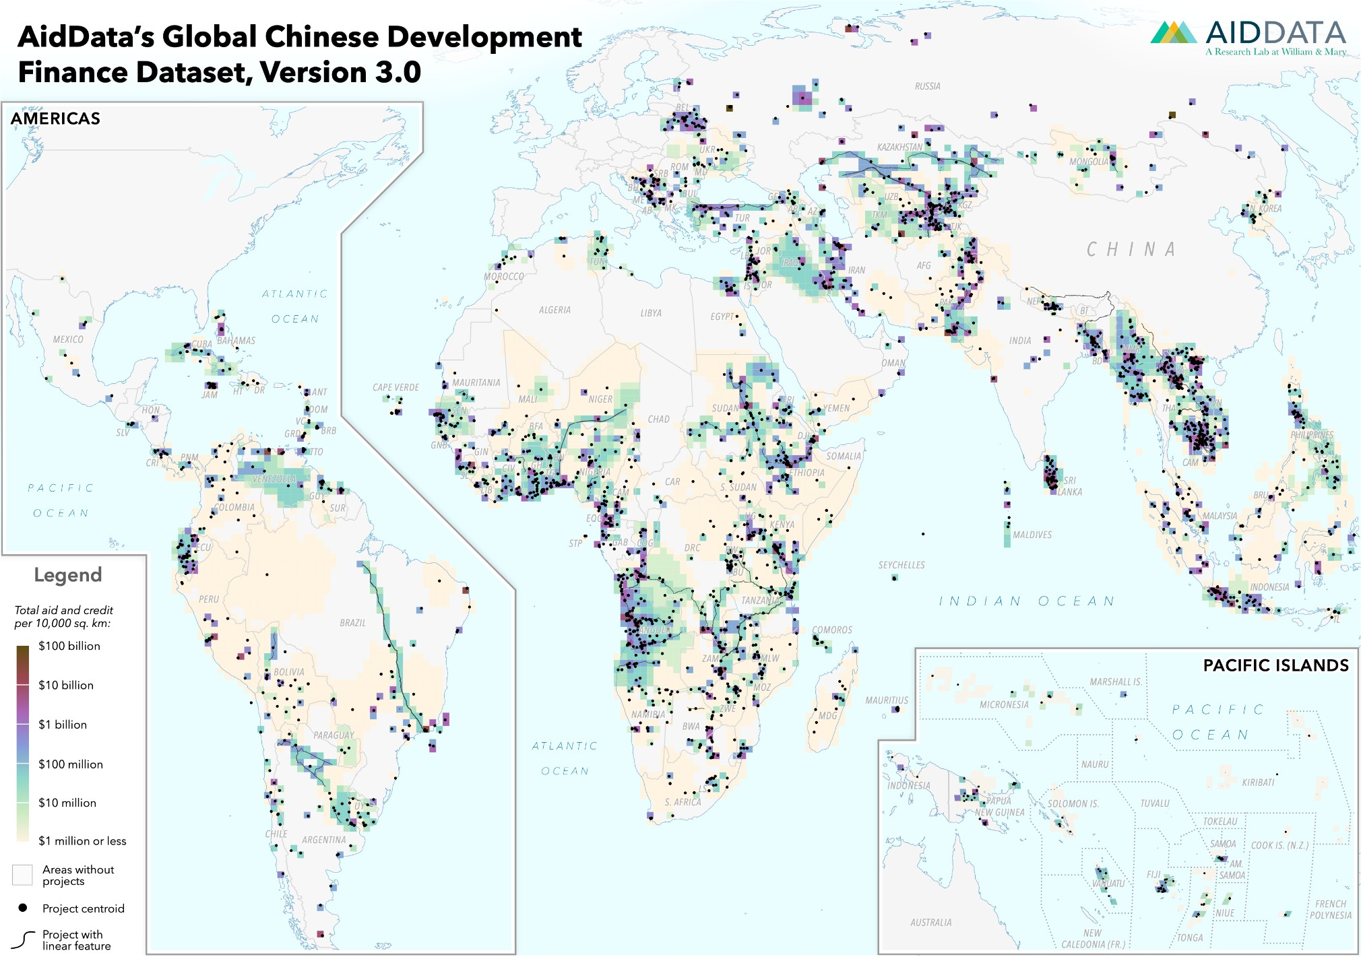

*Notes: This map shows the geographic locations of projects supported by Chinese ODA and OOF commitments across all LICs and MICs between 2000 and 2021. Only projects from the 3.0 version of*

*AidData’s GCDF dataset that have physical footprints or involve speciﬁc locations are represented. Goodman et al. (2023) describes the process by which these point, polygon, and line vector data were generated.*

When AidData released the 2.0 version of the GCDF dataset in September 2021, it provided evidence that China was outspending the U.S. in the developing world on at least a 2-to-1 basis.[12] The 3.0 version of the GCDF dataset demonstrates that China remains the single largest source of international development ﬁnance in the world. In 2021, ofﬁcial ﬁnancial ﬂows (ODA and OOF commitments) from China to LICs and MICs amounted to $79 billion (see Figure 1.2).[13] None of China’s peers or rivals have overseas lending and grant-giving programs that are comparable in scale. In 2021, no single member of the G7 provided ofﬁcial ﬁnancial ﬂows to LICs and MICs in excess of $61 billion.[14] China also outspent all multilateral sources of international development ﬁnance. The single largest multilateral source of international development ﬁnance in 2021 was the World Bank, with international development ﬁnance commitments worth approximately $53 billion.

According to the conventional wisdom among think tanks and media outlets, Beijing made a concerted effort to rein in the BRI after 2017 (Lu 2023; Olander 2023; Do Rosario and Savage 2023) and its annual development ﬁnance commitments plummeted to nearly zero by 2021 (Gallagher and Ray 2020; Hwang et al. 2022; Ray 2023; Myers and Ray 2023; Moses et al. 2023).[15] However, the 3.0 version of AidData’s GCDF dataset debunks the myth that Beijing’s overseas development program has experienced a total collapse. With more complete data on the full range of China’s lending and grant-giving activities in LICs and MICs, it shows a far less dramatic decline in overseas spending during the late BRI period: ofﬁcial ﬁnancial ﬂows (ODA and OOF commitments) from China to LICs and MICs declined from $115 billion in 2018 to $104 billion in 2019 and $74 billion in 2020, before increasing to $79 billion in 2021 (see Figure 1.2).[16]

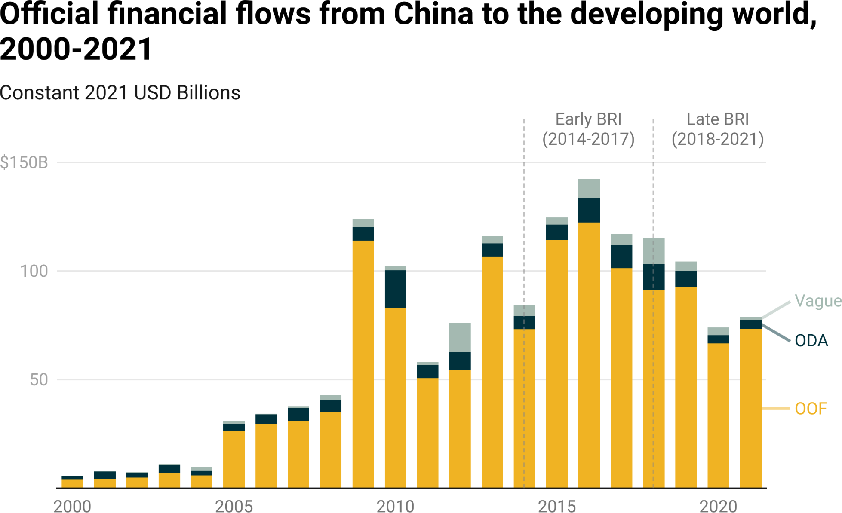

**Figure 1.2**

*Notes: AidData relies on OECD-DAC measurement criteria to make ODA and OOF determinations (see Section A-2 of the Appendix for details). The Vague (Ofﬁcial Finance) is a residual category for ofﬁcial ﬁnancial commitments from China that could not be reliably categorized as ODA or OOF because of insufﬁciently detailed information.*

In Chapter 2, we set the record straight by demonstrating that a sharp decline in dollar-denominated, bilateral lending for public investment projects did indeed take place between 2018 and 2021, but it was offset to a signiﬁcant extent by contemporaneous increases in RMB-denominated, bilateral emergency rescue lending and increases in non-emergency lending via syndication and multilateralization. We also provide evidence that, although Beijing is reducing its reliance on the policy banks, it is ratcheting up its use of the country’s state-owned commercial banks and central bank.

The scale of China’s ambition as a global development ﬁnancier becomes even clearer in an analysis of “stocks” rather than “ﬂows.”[17] Figure 1.3 provides evidence that the inﬂation-adjusted value of Beijing’s 21st-century overseas development ﬁnance portfolio reached the $745 billion mark by the ﬁrst full year of BRI implementation (2014) and surpassed the $1 trillion mark by the fourth full year of BRI implementation (2017). The portfolio continued to expand in subsequent years—so much so that it exceeded $1.3 trillion in 2021.[18] Figure 1.4 presents the cumulative amount of Chinese ODA and OOF from 2014 to 2021 and compares it to cumulative amounts of ODA and OOF from each member of the G7 over the same time period. China’s overseas development program is vastly larger than that of any G7 member, including the U.S. Beijing has outspent Washington in LICs and MICs on a more than two-to-one basis since the BRI was launched.[19] Between 2014 and 2021, ofﬁcial ﬁnancial ﬂows from China to the developing world amounted to $680 billion, while those from the U.S. amounted to $319 billion.[20] Over the same time period, China also outspent the single largest source of multilateral development ﬁnance—the World Bank—on a more than two-to-one basis.[21]

**Figure 1.3**

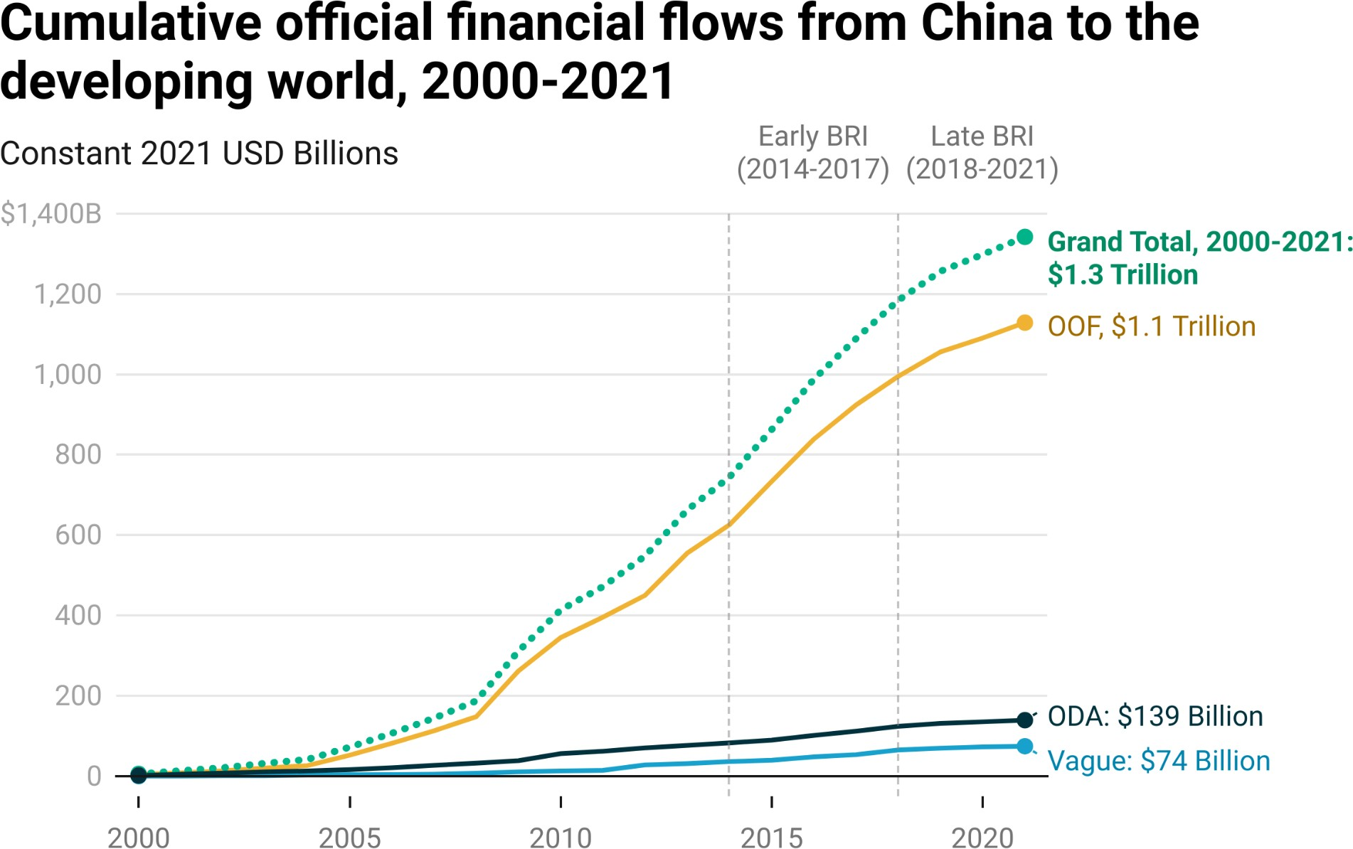

*Notes: AidData relies on OECD-DAC measurement criteria to make ODA and OOF determinations (as described in Section A-2 of the Appendix). The Vague (Ofﬁcial Finance) is a residual category for ofﬁcial ﬁnancial commitments from China that could not be reliably categorized as ODA or OOF because of insufﬁciently detailed information. This ﬁgure excludes short-term "rollover" facilities from the tally of ofﬁcial ﬁnancial commitments (see Box 2c and Section A-3 in the Appendix).*

**Figure 1.4**

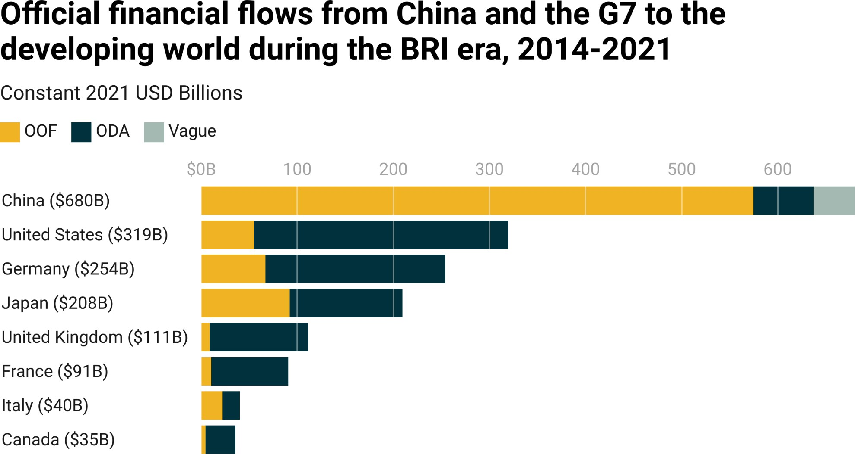

*Notes: AidData relies on OECD-DAC measurement criteria to make ODA and OOF determinations (as described in Section A-2 of the Appendix). The Vague (Ofﬁcial Finance) is a residual category for ofﬁcial ﬁnancial commitments from China that could not be reliably categorized as ODA or OOF because of insufﬁciently detailed information. G7 ODA and OOF data represent gross disbursements from the OECD-DAC. This ﬁgure excludes short-term “rollover” facilities from the tally of ofﬁcial ﬁnancial commitments (see Box 2c and Section A-3 in the Appendix).*

At the same time, there is evidence that the U.S. is beginning to close the overseas development spending gap with China (see Figure 1.5). During the early BRI period (2014-2017), China outspent the U.S. on a nearly three-to-one basis. However, during the late BRI period (2018-2021), Beijing spent $2.33 for every overseas development dollar spent by Washington. The gap narrowed even more during the last year for which reliable data are available: Beijing only spent $1.30 for every overseas development dollar spent by Washington in 2021.[22]

**Figure 1.5**

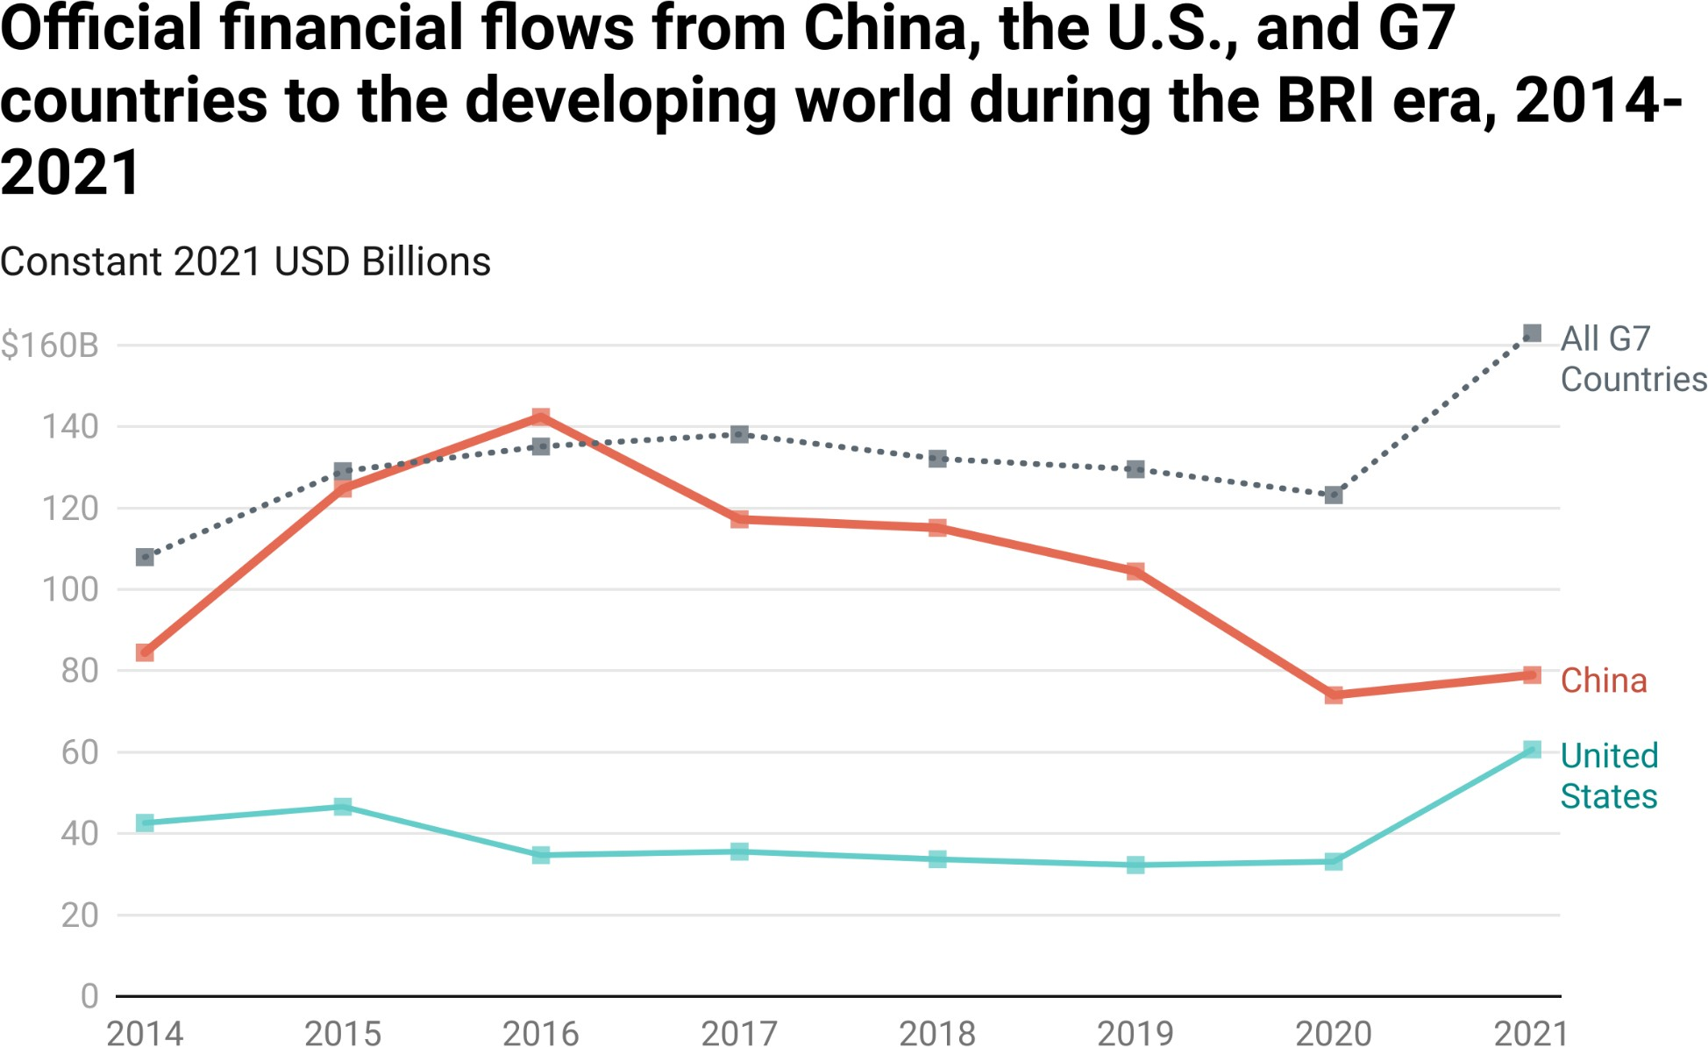

*Notes: This ﬁgure measures ofﬁcial ﬁnancial ﬂows (ODA and OOF commitments) from China, the U.S. and G7 countries to LICs and MICs from 2014 to 2021. AidData relies on OECD-DAC measurement criteria to make ODA and OOF determinations (as described in Section A-2 of the Appendix). The U.S. and G7 ODA and OOF data represent gross disbursements from the OECD-DAC.*

Figure 1.6 demonstrates that the U.S. gained ground on China in 2021 due to a ﬁfteen-fold (1,423%) increase in OOF expenditure.[23] In 2020, OOF represented just 4% of the U.S. international development ﬁnance portfolio; the remaining 96% consisted of ODA. However, one year later, the percentage of U.S. international development ﬁnance provided via OOF soared to 36%. This major compositional change in U.S. development expenditure suggests that Washington is seeking to compete with Beijing via emulation rather than differentiation.[24]

**Figure 1.6**

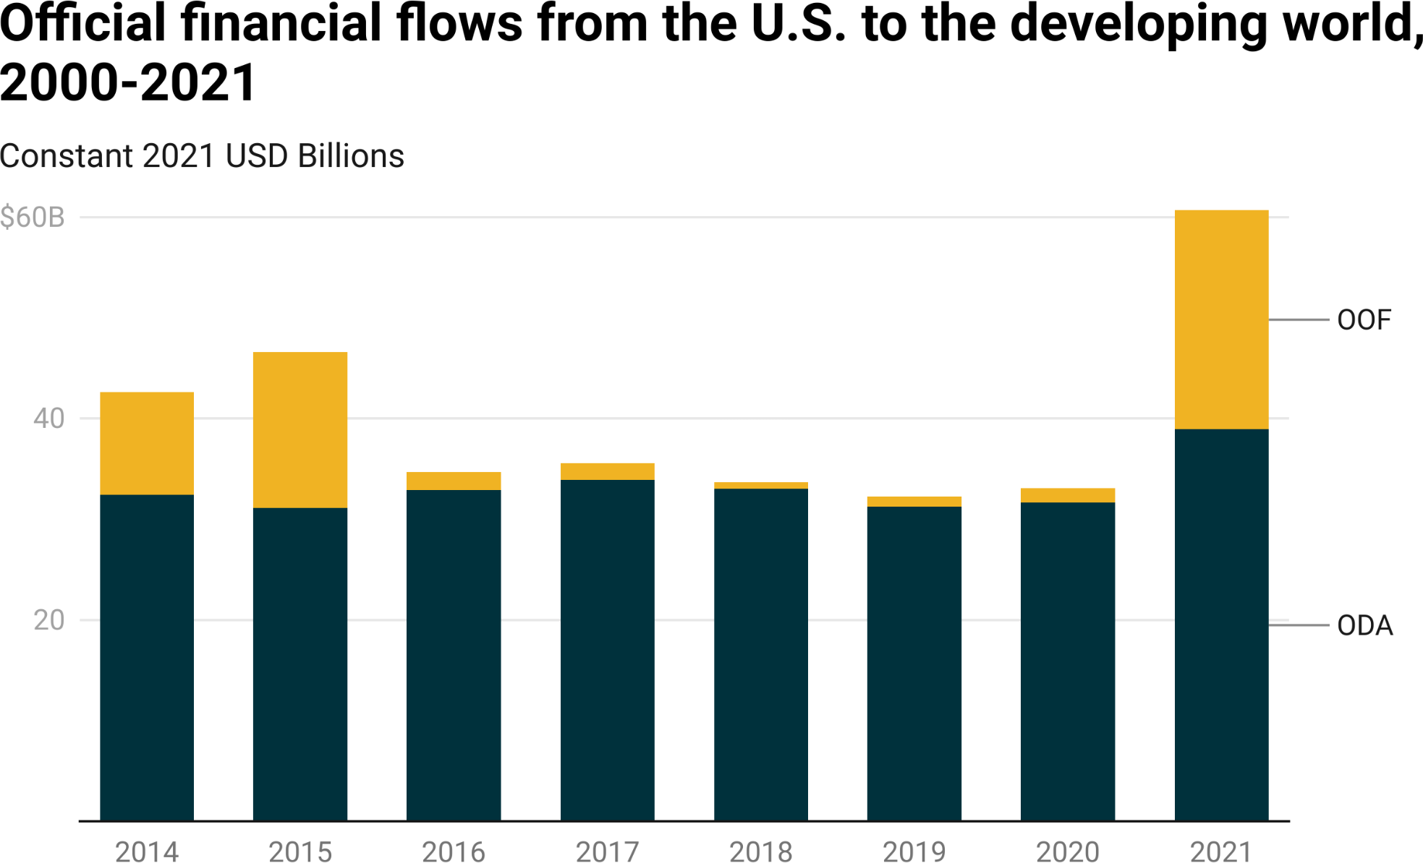

*Notes: U.S. ODA and OOF ﬂows reﬂect gross disbursements (as OOF commitment data are not published by the OECD-DAC for individual DAC members).*

The $20.3 billion increase in OOF that took place in 2021 was the result of an expansion in the overseas activities of the U.S. International Development Finance Corporation (DFC).[25] In October 2018, the U.S. Congress passed the Better Utilization of Investment Leading to Development (BUILD) Act, which established the DFC as a “full service” development ﬁnance institution to help the U.S. “outcompete” China around the globe.[26] However, the DFC did not become fully operational until 2021. One of its earliest (attempted) transactions was a $2.8 billion loan in January 2021 to help the Government of Ecuador repay some of its outstanding debts to China ahead of schedule, in exchange for a commitment to exclude Chinese companies from its telecommunications networks.[27] The proposed borrowing terms of the DFC loan were non-concessional in nature: an 8-year maturity, a 1-year grace period, and an interest rate of LIBOR plus a 2.25% margin.[28] At the time, DFC CEO Adam Boehler said that the loan would “reﬁnance predatory Chinese debt and help Ecuador improve the value of its strategic assets.”[29]

But U.S. spending patterns do not provide the full picture because Washington is seeking to outcompete China by partnering with its allies in London, Paris, Berlin, Tokyo, Rome, and Ottawa. G7 efforts to compete with China are gathering steam. During the early BRI period (2014-2017), China and the G7 were effectively matching each other dollar-for-dollar: for every overseas development dollar that China spent, the G7 spent $1.09.[30] However, during the late BRI period (2018-2021), the G7 stepped up its efforts, spending $1.47 for every overseas development dollar spent by China (see Figure A2 in the Appendix).[31] By 2021, the G7 was outspending China on a nearly two-to-one basis (see Figure 1.5).[32]

As the U.S. and its allies seek to compete with China by rolling out ﬂagship infrastructure programs (like the Partnership for Global Infrastructure and Investment and the India-Middle East-Europe Economic Corridor Initiative) and ramping up non-concessional lending (OOF), a strategic pivot is underway in Beijing. Figure 1.7 provides evidence of major changes in the sectoral composition of China’s overseas development ﬁnance portfolio between 2014 and 2021.[33] Beijing was for the most part focused on providing credit for large-scale infrastructure projects during the early BRI (or BRI 1.0) era. Yet, as we explain at greater length in Chapter 2, it ramped down infrastructure project lending and ramped up emergency rescue lending during the late BRI (or BRI 2.0) period. Beijing made this course correction in order to adapt to a new reality: the fact that many of its largest borrowers were having serious difﬁculty repaying their infrastructure project debts.[34]

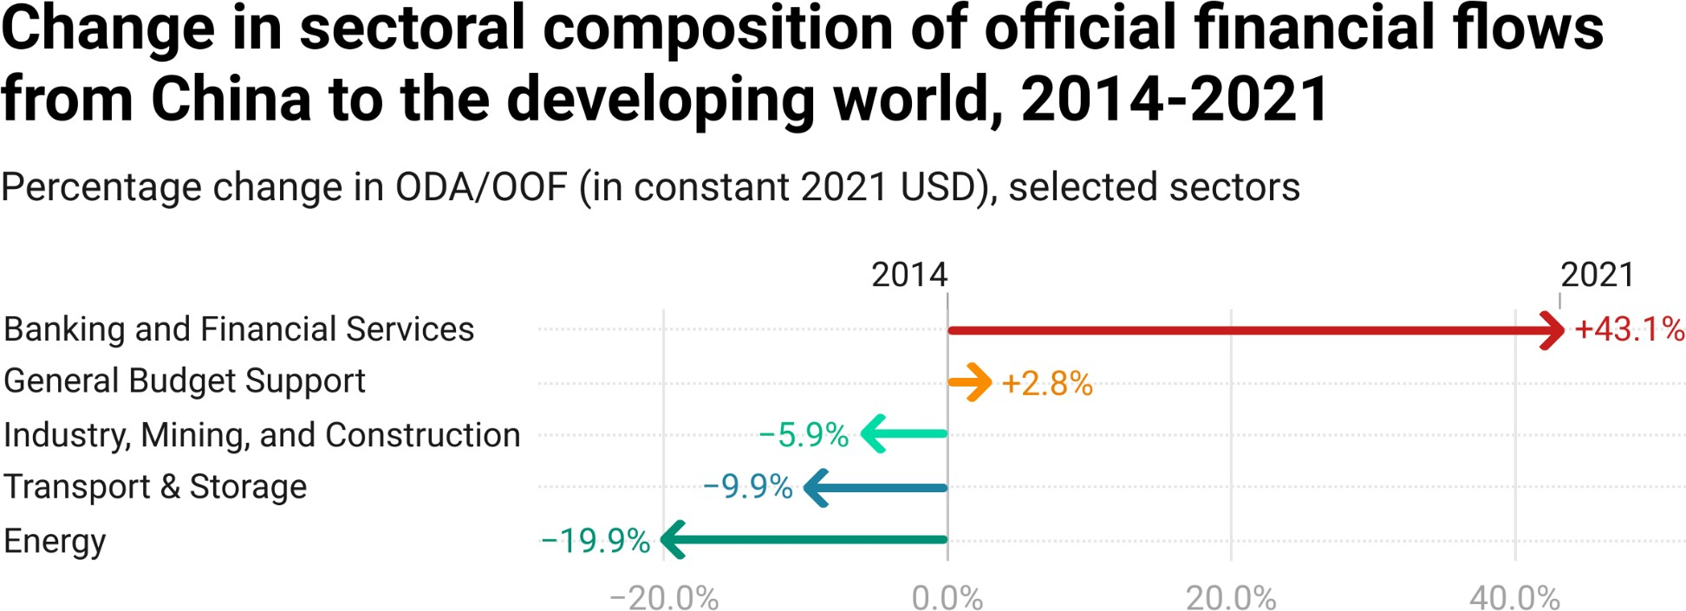

**Figure 1.7**

*Notes: This ﬁgure, which relies on 3-digit OECD sector codes from the 3.0 version of AidData’s GCDF dataset, presents proportional changes in the sectoral composition of Chinese ODA and OOF commitments (measured in constant 2021 USD) to LICs and MICs between 2014 and 2021. Figure A3 in the Appendix provides supplementary evidence on sectoral changes over the same time period.*

There are glass-half-full and glass-half-empty ways of interpreting G7 efforts to compete with China. The glass-half-full view is that Beijing is ceding its leadership in the global infrastructure space and the G7 is seeking to ﬁll the vacuum, which may help address the large, unmet infrastructure ﬁnancing needs of developing countries. The glass-half-empty view is that the G7 is misreading the demand signal from the Global South and seeking to compete with a version of the BRI (BRI 1.0) that no longer exists. After recently going on a borrowing spree for big-ticket infrastructure projects, low-income and middle-income countries may have less appetite for expensive infrastructure and more appetite for balance of payments support that will keep them aﬂoat during a time when global economic conditions are highly unfavorable (as interest rates rise, the dollar strengthens, local currencies weaken, and economic growth slows).

### Section 3: Repayment risk from Beijing’s perspective

Beijing’s pivot away from infrastructure project lending and toward emergency rescue lending is as much about supply-side pressures as it is about demand-side pressures. After the Belt and Road Initiative was launched, Chinese state-owned creditors went on a lending spree, issuing thousands of loans for big-ticket infrastructure projects spread across 129 countries in the developing world. However, they did so without strong risk management guardrails in place. They lent to borrowers with bad credit ratings or no credit ratings (like Laos, Tajikistan, Zambia, South Sudan, Suriname, Zimbabwe, Pakistan, and Argentina); banked on borrowers being able to repay loans with the cash proceeds from natural resource exports (like Angola, Equatorial Guinea, Ecuador, Venezuela, Congo-Brazzaville, and Turkmenistan); and issued dollar- and euro-denominated loans to countries (like Russia, Belarus, Myanmar, Sudan, Iran, and Cuba) that would later be unable to transact in those currencies due to international sanctions.

Now, Chinese state-owned creditors are saddled with many underperforming loans and want to ensure that their overseas borrowers are sufﬁciently liquid to continue servicing their existing infrastructure project debts.[35] They are responding to this challenge in two ways, which we document in greater detail in Chapter 2: debt reschedulings that provide short-term cash ﬂow relief to borrowers and emergency rescue loans that help borrowers shore up their foreign exchange reserves and repay existing (infrastructure project) debts.

**Figure 1.8**

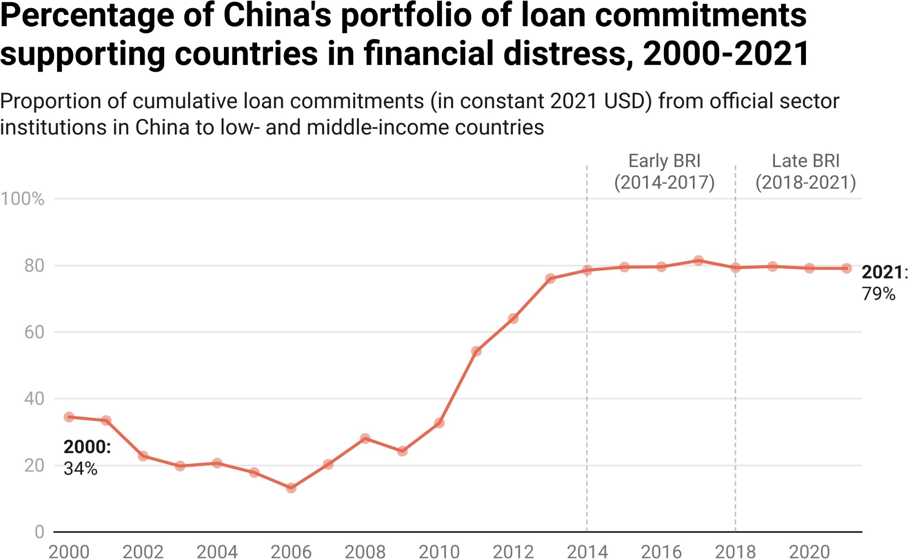

*Notes: MOFCOM interest-free loan commitments (which are typically issued without a credible expectation of repayment) and emergency rescue loan commitments (responses to ﬁnancial distress) are excluded from the calculation. To determine if a country was experiencing ﬁnancial distress in a given year, we use the binary measure described in Box 1a.*

**Figure 1.9**

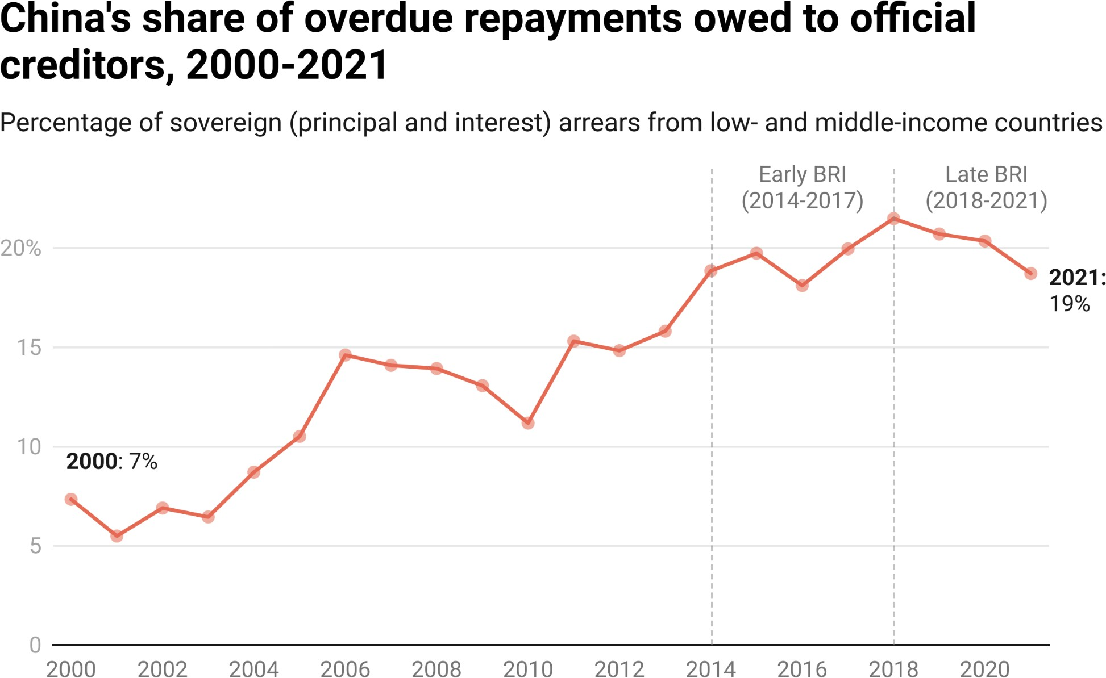

*Notes: Sovereign arrears capture principal and interest arrears (i.e., overdue repayments) on PPG debt to China Eximbank, China Development Bank, and China’s Ministry of Commerce contracted by a subset of LICs and MICs that participate in the World Bank’s Debtor Reporting System (DRS). Each country-year observation is given equal weight in a given year to generate global averages. Years in which a country maintained diplomatic relations with Taiwan are excluded. The data are drawn from the World Bank’s International Debt Statistics.*

Figures 1.8, 1.9, and A4 in the Appendix highlight the scope and severity of the challenge. Until 2008, Beijing never had to deal with more than 10 ﬁnancially-distressed countries with unpaid debts to Chinese state-owned creditors; however, by 2021, at least 57 countries with outstanding debt to China were in ﬁnancial distress (see Figure A4).[36] In 2000, 34% of China's overseas lending portfolio supported borrowers in ﬁnancial distress.[37] By 2021, that ﬁgure skyrocketed to 79% (see Figure 1.8).[38]

#### Box 1a: How AidData identiﬁes when China’s borrowers are experiencing ﬁnancial distress

Figure A4, Figure 1.8 and other graphs and tables in this report require a measure of when countries have borrowed from China under normal circumstances and when countries have borrowed from China during periods of ﬁnancial distress. In order to determine whether and when a borrower country experienced a ﬁnancial distress episode, we identify if it met any one of the following conditions in a given year:

* It registered a score of 5 or less on the sovrate index produced by the World Bank;
* Its overdue repayments on public debt to China were equal to or greater than 10% of its of total outstanding public debt to China (as measured by the World Bank); or
* One or more of its ofﬁcial sector loans from China—that are within their originally scheduled repayment periods—showed signs of ﬁnancial distress (as measured by the 3.0 version of AidData’s GCDF dataset).

The World Bank’s sovrate index is a measure of repayment risk—based on average sovereign credit ratings from Moody’s, Standard & Poor’s, and Fitch—that varies from 0 to 21, with higher scores indicating lower levels of sovereign credit risk (Kose et al. 2022). Countries with scores of 0-5 are in “C and D territory” on the measures produced by the *Big Three* credit rating agencies—i.e., they are in default or at a high risk of default (Teixeira et al. 2018; Séri et al.

2021).[39] The data on overdue loan repayments to China are drawn from the World Bank’s International Debt Statistics (IDS), which is based on voluntary reporting by 119 low-income and middle-income countries. We use these data to measure whether a country’s principal and interest arrears on public and publicly guaranteed (PPG) debt to ofﬁcial sector creditors in China are equal to or greater than 10% of its total outstanding PPG debt to ofﬁcial sector creditors in China.[40] We also use a variable from the 3.0 version of AidData’s GCDF dataset that measures on

a *loan-by-loan basis* whether the borrower had difﬁculty making repayments or showed signs of ﬁnancial distress during the repayment period.41

Our measure of whether a given borrower country experienced a ﬁnancial distress episode is reset to 0 (“turns off”) in a given year if the country's sovrate score exceeds 5.0, its overdue repayments on public debt to China are no longer equal to or greater than 10% of its of total outstanding public debt to China, and none of its loans from ofﬁcial sector creditors in China (that are within their originally scheduled repayment periods) show signs of ﬁnancial distress.

Another useful gauge of the health of China’s overseas lending portfolio is the extent to which its borrowers are falling behind on their repayments to Chinese creditors (in comparison to other external creditors). Figure 1.9 tracks the percentage of all overdue payments (principal and interest arrears) from low-income and middle-income governments to all ofﬁcial creditors that are owed to creditors in China. It shows that a rapidly growing proportion of overdue loan repayments are owed to Chinese state-owned creditors. This ﬁgure more than doubled—from 7% in 2000 to 19% in 2021.[42]

### Section 4: Project performance risk from Beijing’s perspective

Beijing has channeled an extraordinary amount of aid and credit to the developing world for large-scale infrastructure projects. According to the 3.0 version of AidData’s GCDF dataset, which includes a new measure of whether projects involve the construction, rehabilitation, expansion, or maintenance of physical infrastructure, ofﬁcial sector donors and lenders in China issued 4,800 grants and loans (worth $825 billion) for infrastructure projects in 140 developing countries between 2000 and 2021.[43] Infrastructure projects are notoriously difﬁcult to implement (for reasons that we discuss at greater length in Chapter

3). Therefore, an important part of Beijing’s portfolio management challenge is dealing with project performance risk.

The 3.0 version of AidData’s GCDF dataset is different from other publicly available datasets of Chinese development ﬁnance in that it captures project suspensions and cancellations (see Figure A6). We have previously encountered criticism for publishing data on infrastructure—and non-infrastructure—projects backed by ofﬁcial commitments that are subsequently suspended or canceled.[44] However, we maintain that it is important to systematically track these projects and subject them to analysis. Shielding suspended and canceled projects from public scrutiny leaves analysts and decision-makers with an incomplete picture of Beijing’s overseas development program. It also limits opportunities to learn from failure.

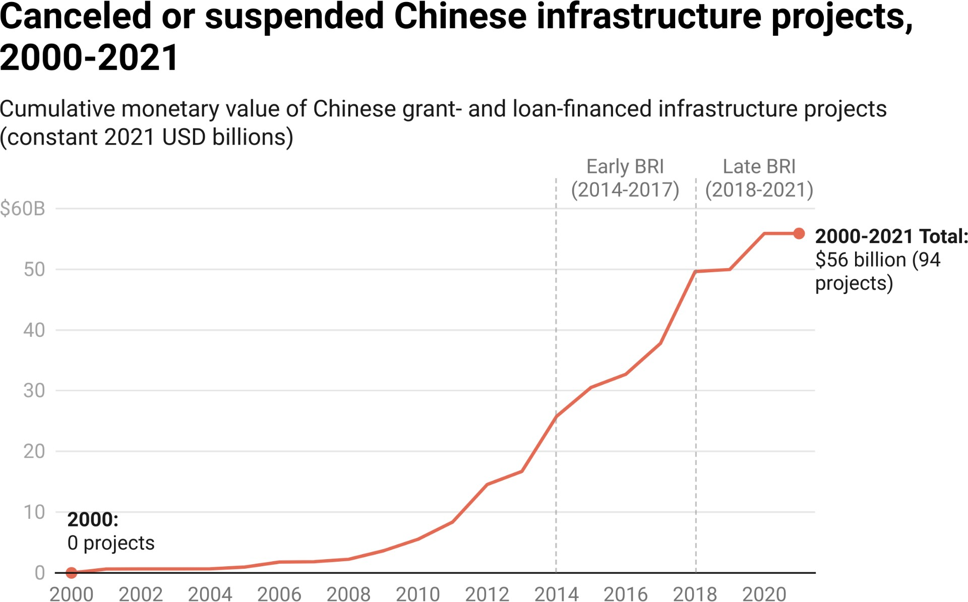

**Figure 1.10**

*Notes: Based on Chinese ODA- and OOF-ﬁnanced projects (including those canceled or suspended since 2000) marked as “infrastructure” in the 3.0 version of AidData’s GCDF dataset. No projects that were committed in the year 2000 were subsequently canceled or suspended.*

Figure 1.10 demonstrates that suspensions and cancellations of infrastructure projects have rapidly accumulated over time. By 2021, 94 infrastructure projects in 49 countries secured Chinese grant and loan commitments worth $56 billion that were subsequently suspended or canceled. These projects are likely viewed by Beijing as evidence of BRI buyer’s remorse, as 80% of the suspensions and cancellations that took place between 2014 and 2021 were in BRI participant countries.[45] However, this method of measurement is a conservative, lower-bound estimate of the total number of infrastructure projects that China unsuccessfully sought to bankroll and build, as it excludes those that were shelved before securing ﬁnancial commitments (Lu et al. 2023b).[46]

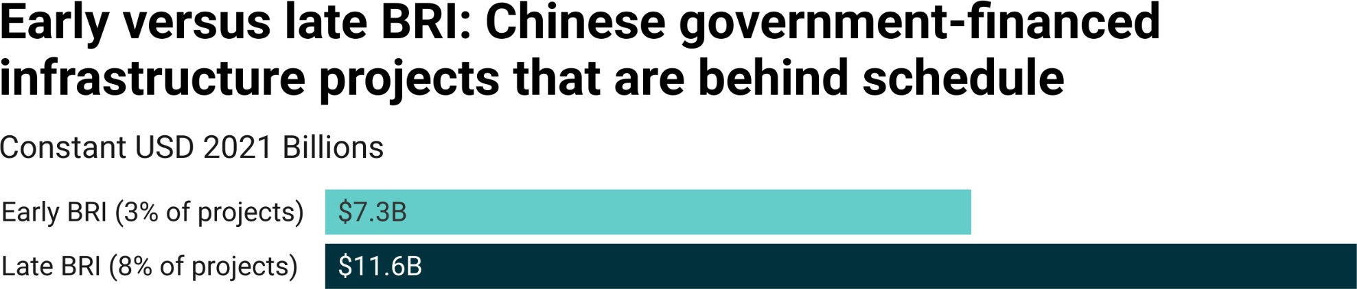

**Figure 1.11**

*Notes: “Behind schedule” is deﬁned as Chinese ODA- and OOF-ﬁnanced projects where the actual implementation start date took place 3 months or more after its originally scheduled implementation start date, as well as projects where the actual completion date took place 3 months (or more) after its originally scheduled completion date.*

Another source of implementation risk and potential cause for concern is the increase in the proportion of Beijing’s infrastructure project portfolio running behind schedule between the early BRI period and the late BRI period (see Figure 1.11).[47] However, this measure of whether a project is running behind schedule captures two different types of delays: commencement delays and completion delays.[48] More speciﬁcally, it measures whether a project’s (a) actual implementation start date took place 3 months after its scheduled implementation start date or longer, and/or (b) its actual completion date took place 3 months after its scheduled completion date or longer. When this summary metric is unbundled into its constituent parts, a more complex and nuanced picture of China’s overseas infrastructure project portfolio emerges.

Figure 1.12 demonstrates that, while commencement delays have increased, completion delays have not. The average commencement delay increased by 32 days between the early BRI period and the late BRI period, while the average completion delay shrank by 59 days over the same two time periods.[49]

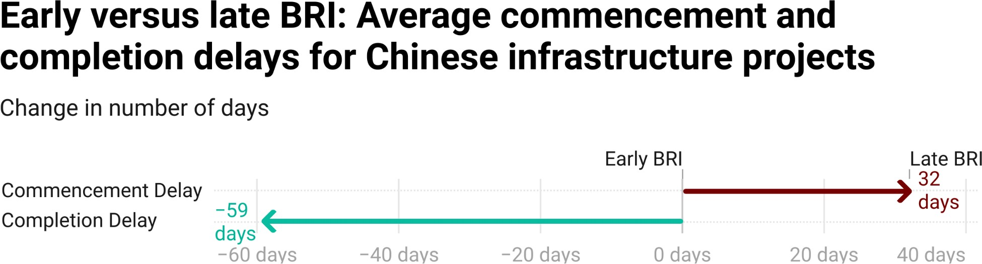

**Figure 1.12**

*Notes: This ﬁgure is based on active and completed infrastructure projects ﬁnanced with Chinese ODA and OOF. Delays are calculated by taking the difference (in calendar days) between the originally scheduled project implementation start date/completion date and the actual project implementation start date/completion date (respectively).*

The fact that a shrinking proportion of infrastructure projects launch on their originally scheduled commencement dates could be related to several different factors. One possibility is that Chinese contractors and/or their host country counterparts are increasingly expected to comply with environmental, social, or governance (ESG) standards prior to the start of project implementation—or they are underestimating the difﬁculty of meeting these standards before infrastructure projects can get underway.[50] A separate but related possibility is that Chinese lenders are asking their borrowers to meet more ESG conditions (so-called “conditions precedent”) prior to the date of the ﬁrst loan disbursement, which typically precedes the start of project implementation. We address these issues at greater length in Chapter 3. Another possibility, which we address in Chapter 4, is that host country politicians are increasingly reluctant to “claim credit” for infrastructure projects ﬁnanced by China via high-proﬁle groundbreaking ceremonies.

At the same time, not all of the lights on Beijing’s project performance dashboard are “ﬂashing red.” Chinese lenders and contractors have evidently learned how to reduce the likelihood that overseas infrastructure projects will not be ﬁnished on time—and the length of any delays that do take place during project implementation. These improvements could be the result of better planning (more realistic forecasting of how long it takes to complete projects) or fewer/smaller scope of work deviations by the contractors responsible for project implementation. They also call attention to an important measure that Beijing can take to slow or reverse the rising tide of BRI “buyer’s remorse”: timely completion of projects that improve the provision of public services in host countries. In new work with collaborators from Heidelberg University, the University of Göttingen, and the University of Hong Kong, we provide causal evidence that the *completion* of Chinese development projects increases popular support for the Chinese government in host countries (Wellner et al. forthcoming).[51] We also show in the same study that host country residents are more likely to report satisfaction with the delivery of public services upon the completion of Chinese development projects.

However, Beijing cannot afford to rest on its laurels. Another key ﬁnding from the same study is that these effects erode over time: on average, we ﬁnd that the completion of one additional Chinese development project increases public support for the Chinese government by approximately 3 percentage points in the short run but only 0.2 percentage points in the longer run (Wellner et al. forthcoming).

Beijing also faces a daunting set of ESG risks in its overseas development program. In Chapter 3, we develop and analyze a new composite measure of ESG risk that captures whether a given Chinese grant- or loan-ﬁnanced infrastructure project (1) took place in an area that is environmentally sensitive, socially sensitive, or vulnerable to political capture and manipulation; (2) relied on contractors sanctioned by other international ﬁnanciers for fraudulent and corrupt behavior; or (3) encountered a signiﬁcant environmental, social, or governance problem before, during, or after implementation. Figure 1.13, which draws upon this measure, indicates that the cumulative number of Chinese grant- and loan-ﬁnanced infrastructure projects in LICs and MICs with signiﬁcant ESG risk exposure increased from 17 projects in 16 countries in 2000 to 1,693 projects in 125 countries in 2021. As of 2000, Beijing had issued grants and loans worth $420 million for infrastructure projects in LICs and MICs that faced one or more signiﬁcant ESG risks. This ﬁgure increased on a cumulative basis to $470 billion in 2021. The ESG risk prevalence rate, which we deﬁne as the annual percentage of China’s grant- and loan-ﬁnanced infrastructure project portfolio (measured in constant 2021 USD) with signiﬁcant environmental, social, or governance risk exposure, also increased from 12% in 2000 to 33% in 2021 (see Figure 3.2).[52]

**Figure 1.13**

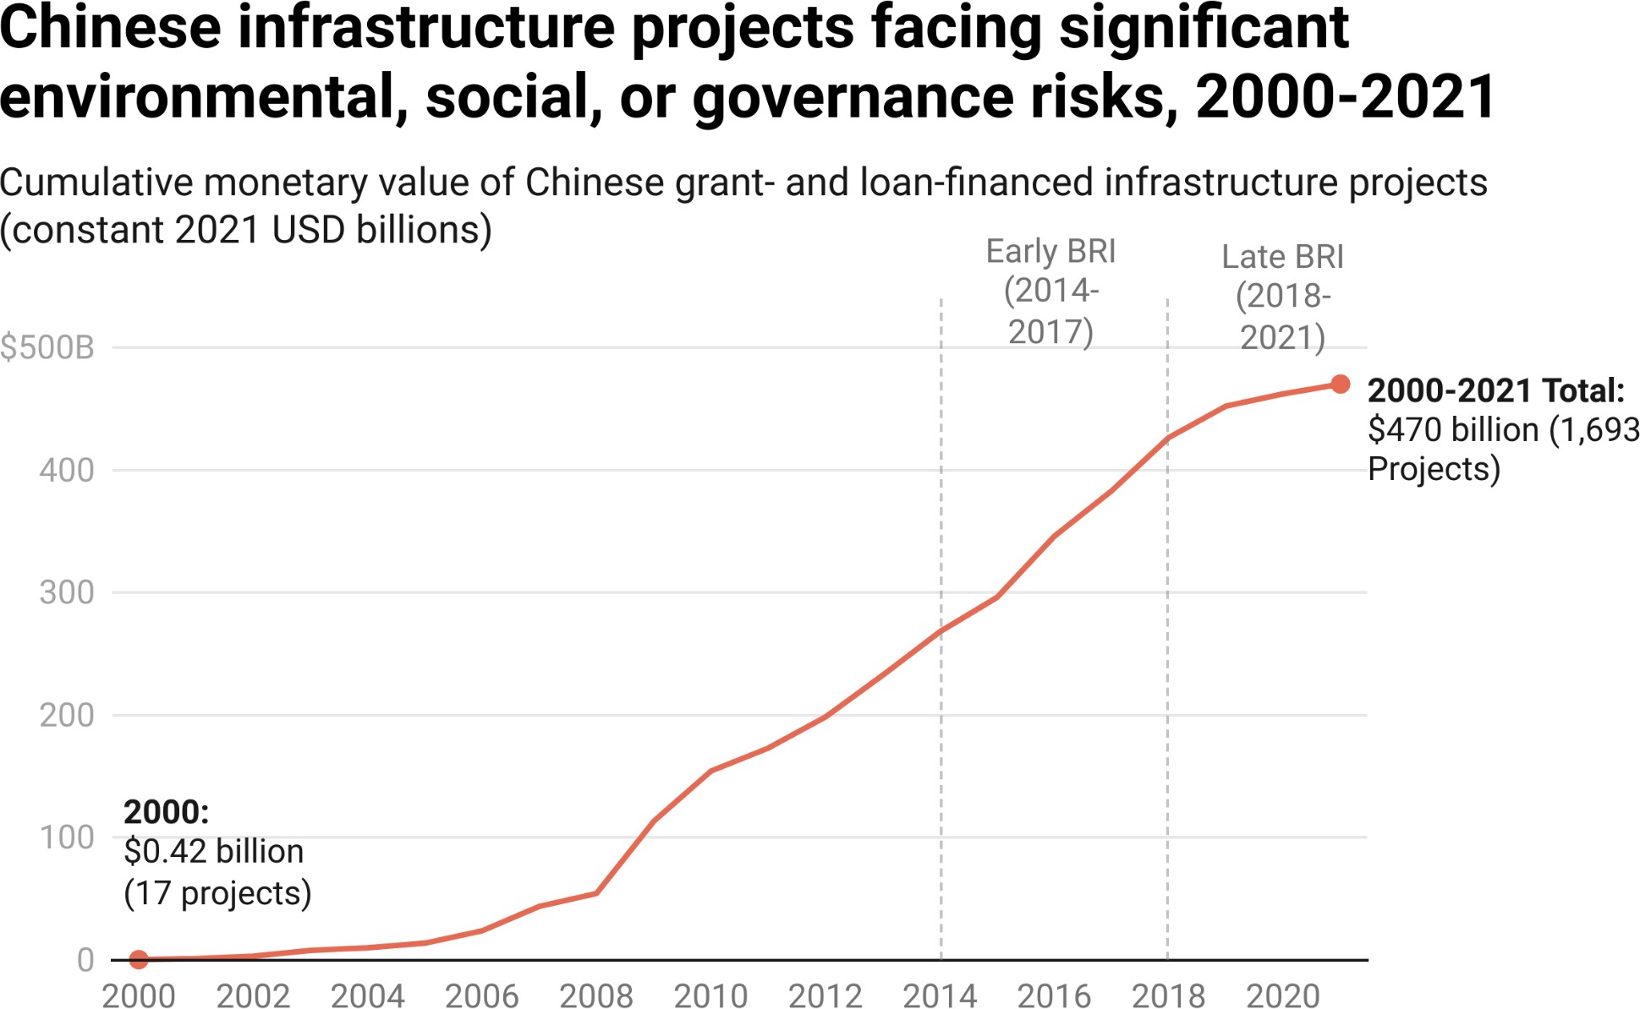

*Notes: The presence of signiﬁcant ESG risk exposure is based on a project-level composite measure that is described in Section 2 of Chapter 3.*

### Section 5: Reputational risk from Beijing’s perspective

Managing the risk proﬁle of China's overseas development program also requires a focus on grassroots, media, and elite support in host countries.[53] In 2014, Xi Jinping made the case for reputational risk management in China’s international activities, arguing that “[w]e should increase China’s soft power, give a good Chinese narrative, and better communicate China’s message to the world” (People’s Daily 2014). Reinforcing this point, a senior ofﬁcial from China’s Ministry of Commerce noted that “the work of foreign aid relates to China’s image. We cannot tolerate any negligence or projects of poor quality” (MOFCOM 2014). More recently, at a September 2023 conference on the 10th anniversary of the BRI, China's Ambassador to the European Union acknowledged that "[w]hen it comes to the BRI, whether it's good or bad, we need to listen more to the receiving countries. We know there is a lot of criticism in the Western media and also from Western governments sometimes but we care more about the reactions from the receiving states, especially in the Global South” (Euractiv 2023).

Figure 1.14 presents data from the Gallup World Poll (GWP) on average levels of public support for the Chinese government and the U.S. government across the developing world during the early BRI (2014-2017) period and the late BRI (2018-2021) period. The GWP data show similar levels of public support for Beijing and Washington during the early BRI period. Both countries saw their approval ratings in the Global South ﬂuctuate between 50% and 60% between 2014 and 2017. However, as the initial momentum behind China’s ﬂagship global infrastructure initiative waned and countries re-evaluated the risks and rewards of their continued participation during the late BRI period, global public opinion vis-à-vis China soured. Beijing suffered a 16 percentage point loss between 2019 and 2021; its public approval rating in low-income and middle-income countries plunged from 56% in 2019 to 40% in 2021.[54] Washington, by contrast, saw its approval rating in the Global South rise by 7 percentage points in 2021, thereby opening up a 14 percentage point advantage over its rival.

performance of the leadership of the United States?”) into two binary indicators that assume values of 1 if a respondent approves of the leadership of China or the leadership of the U.S., respectively.[55] We then calculate the percentage of respondents who approved of the leadership of China or the leadership of the U.S., respectively, at the country-year level.

We measure media sentiment toward China and the U.S. by calculating two sets of average scores—one for China and one for the U.S.—at the country-year from the Global Database of Events, Language, and Tone (GDELT) 1.0 Event Database. We rely on the AvgTone variable, which is algorithmically calculated based on the tone of hundreds of millions of news articles across nearly 200 countries. This measure varies from -100 to +100, with positive scores indicating favorable media coverage related to government actors in mainland China (or the U.S.) and negative scores indicating unfavorable coverage related to government actors in mainland China (or the U.S.).[56] For most countries at most times, AvgTone scores vary between

-10 and +10, with values of 0 indicating neutral media coverage.

We measure elite support for China and the U.S. by assessing the extent to which other governments align their votes in the United Nations General Assembly (UNGA) with each of these foreign powers. The UNGA is a venue in which governments have an opportunity to stake out foreign policy positions that are similar or dissimilar to those adopted by China (or the U.S.). Our measure of UNGA voting alignment with China (or the U.S.) is based on “idealpointdistance” estimates between each country in the 3.0 version of AidData’s GCDF dataset and China (or the U.S.). These estimates are drawn from Version 29.0 of the United Nations General Assembly Voting Data (Bailey et al. 2017) and they are inverted, such that higher values indicate higher levels of UNGA voting alignment with China (or the U.S.).[57]

The global competition for favorable media coverage did not play out in quite the same way. Figure 1.15 demonstrates that, in absolute terms, China outperformed the U.S. on this dimension of soft power in the developing world during both the early BRI period and late BRI period.[58] This pattern is consistent with evidence that Beijing’s grassroots image management strategy involves proactive use of public diplomacy tools to generate more favorable media reporting about China (Brazys and Dukalskis 2019; Custer et al. 2018, 2019). But Beijing’s advantage over Washington was hardly insurmountable; by 2020 and 2021, China had lost ground to the U.S. and was struggling to maintain a razor-thin lead in media coverage favorability.

China’s outsized inﬂuence in the Global South is most clearly evident in the United Nations General Assembly (UNGA), where voting patterns are often used as a proxy for the extent to which governing elites in developing countries align their foreign policy positions with those of the U.S. or China. Figure 1.16 demonstrates that countries in the Global South consistently vote with China rather than the U.S. in UNGA. Although there are some natural foreign policy afﬁnities between China and countries in the Global South, Beijing has a well-established track record of using its largesse to buy votes in international organizations.[59] In joint work with our longtime collaborators from Heidelberg University, the University of Göttingen, the University of Hong Kong, and William & Mary, we show in a new book called Banking on Beijing that when countries vote with China in the UN General Assembly, they are richly rewarded. Our statistical model results imply that if a low-income or middle-income government chooses to increase the alignment of its UNGA voting with China by just 10%, it can expect to see a 276% increase in aid and credit (ODA and OOF commitments) from Beijing, on average (Dreher et al. 2022).[60]

**Figure 1.14**

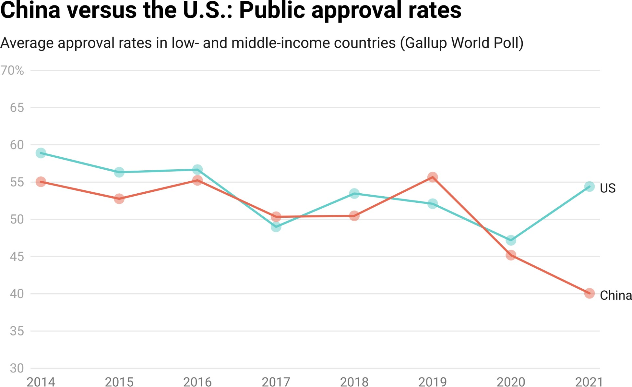

*Notes: Average public approval ratings for China and the U.S. are weighted by country population. The construction of this variable is described in greater detail in Box 1b.*

**Figure 1.15**

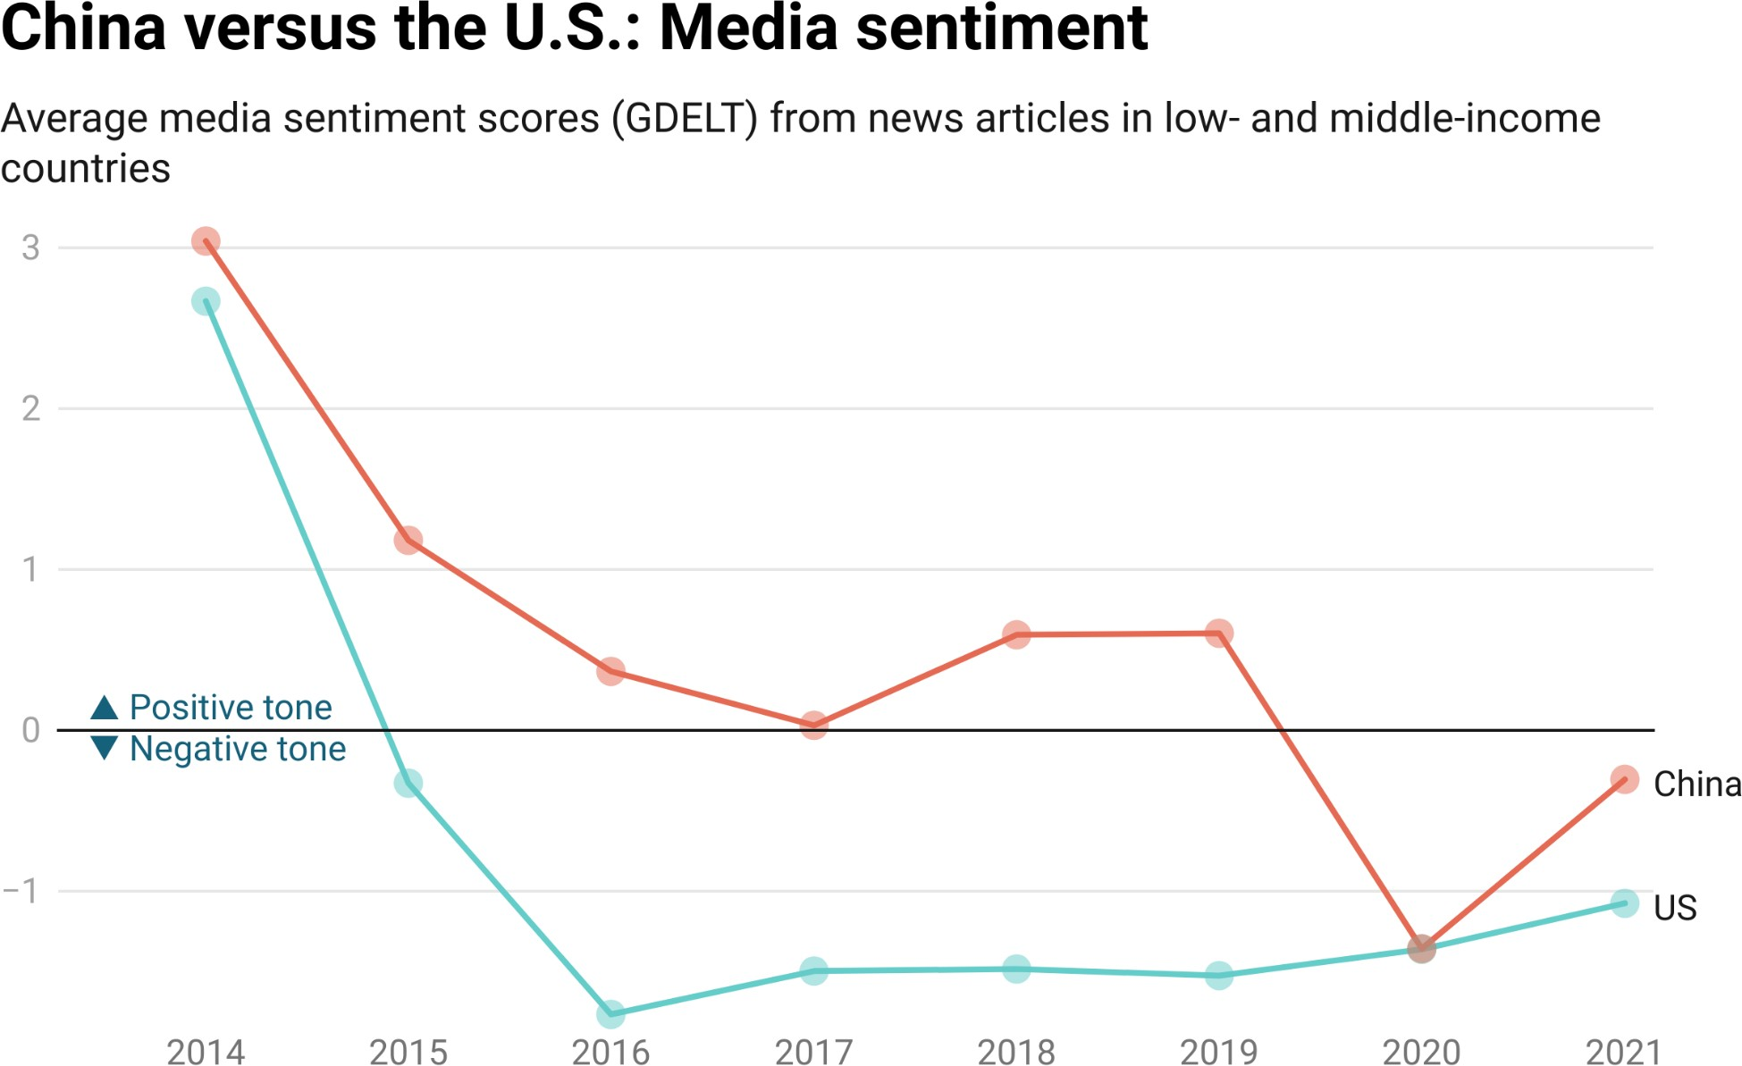

*Notes: Average media sentiment ratings for China and the U.S. are weighted by country population. The construction of this variable is described in greater detail in Box 1b.*

**Figure 1.6**

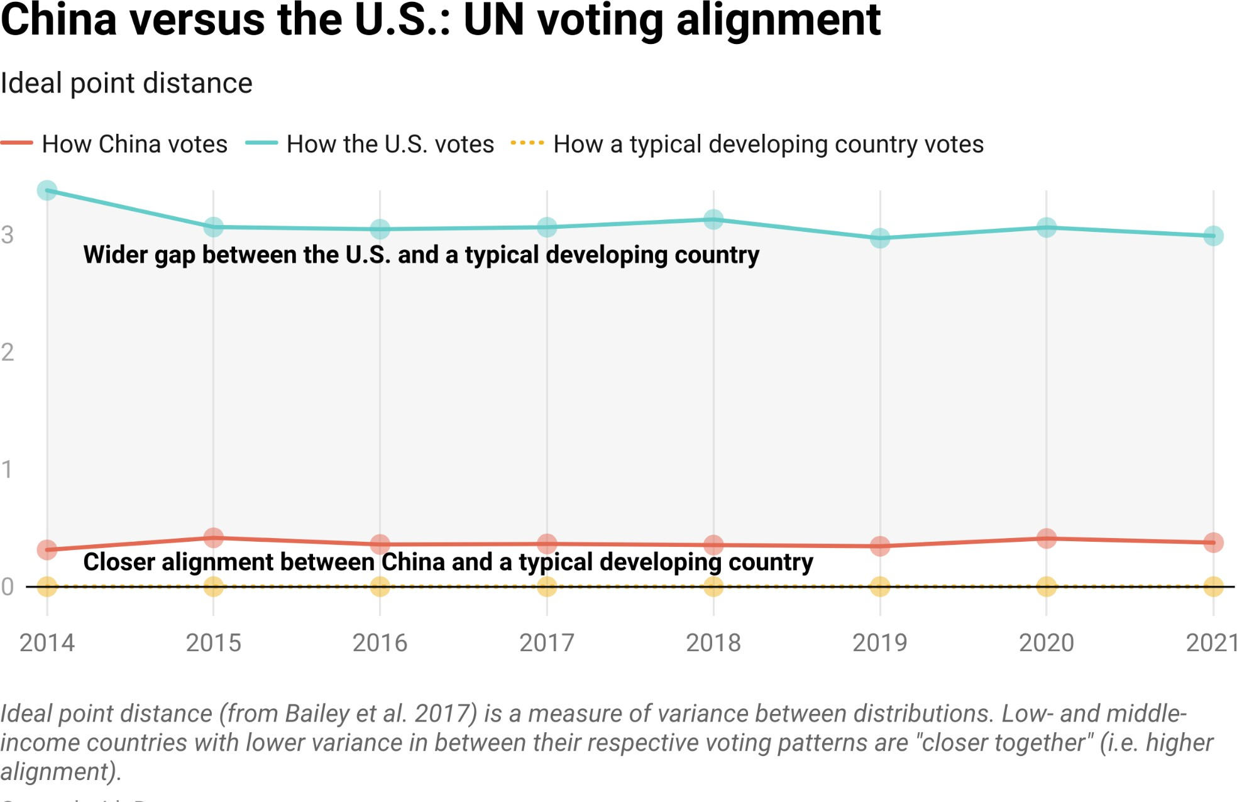

*Notes: Average UNGA voting alignment scores for China and the U.S. are weighted by country population. The construction of this variable is described in greater detail in Box 1b.*

Figure 1.17 tallies the annual number of soft power “gains” and “losses” that China experienced vis-à-vis the U.S. on a country-by-country basis between 2014 and 2021.[61] On all three measures of soft power (public opinion, media sentiment, and elite support), China has experienced more losses than gains vis-à-vis the U.S. since 2014 (the ﬁrst full year of BRI implementation). Public opinion in the developing world has moved in a particularly unfavorable direction for Beijing. During the early BRI period, 39% of the country-level public opinion changes that China experienced were relative losses rather than relative gains (i.e., public opinion toward the U.S. improved at a faster rate than public opinion toward China, or public opinion toward the U.S. declined at a slower rate than public opinion toward China). However, during the late BRI period, this ﬁgure shot up to 66%. By 2021, nearly 85% of the country-level public opinion changes that China experienced were relative losses rather than relative gains (see Figure A8 in the Appendix). Over time, rising levels of public antipathy toward China and expanding popular support for the U.S. have widened Washington’s soft power advantage over Beijing. The battle for hearts and minds in the developing world was effectively a toss-up during the early years of the BRI: Beijing and Washington achieved a similar number of public opinion gains and losses on a country-by-country basis.[62] However, during the late BRI period (2018-2021), Beijing’s losses outnumbered its wins—by a signiﬁcant margin.[63]

Figures 1.18 and 1.19 suggest that Beijing has suffered less acute public opinion and media sentiment losses in BRI participant countries, which is consistent with new research on the international image-enhancing effects of Chinese aid and credit (Wellner et al. forthcoming, 2023; Brazys and Dukalskis 2019).[64] However, even in BRI participant countries, the trend lines have moved in a direction that should provide cold comfort to Beijing. Figure 1.20 provides additional grounds for concern, since it demonstrates that governing elites in BRI participant countries are taking foreign policy positions that are increasingly out of alignment with those of China. Souring media sentiment and declining levels of public support may be making it more difﬁcult for governing elites to maintain close relations with Beijing.

**Figure 1.17**

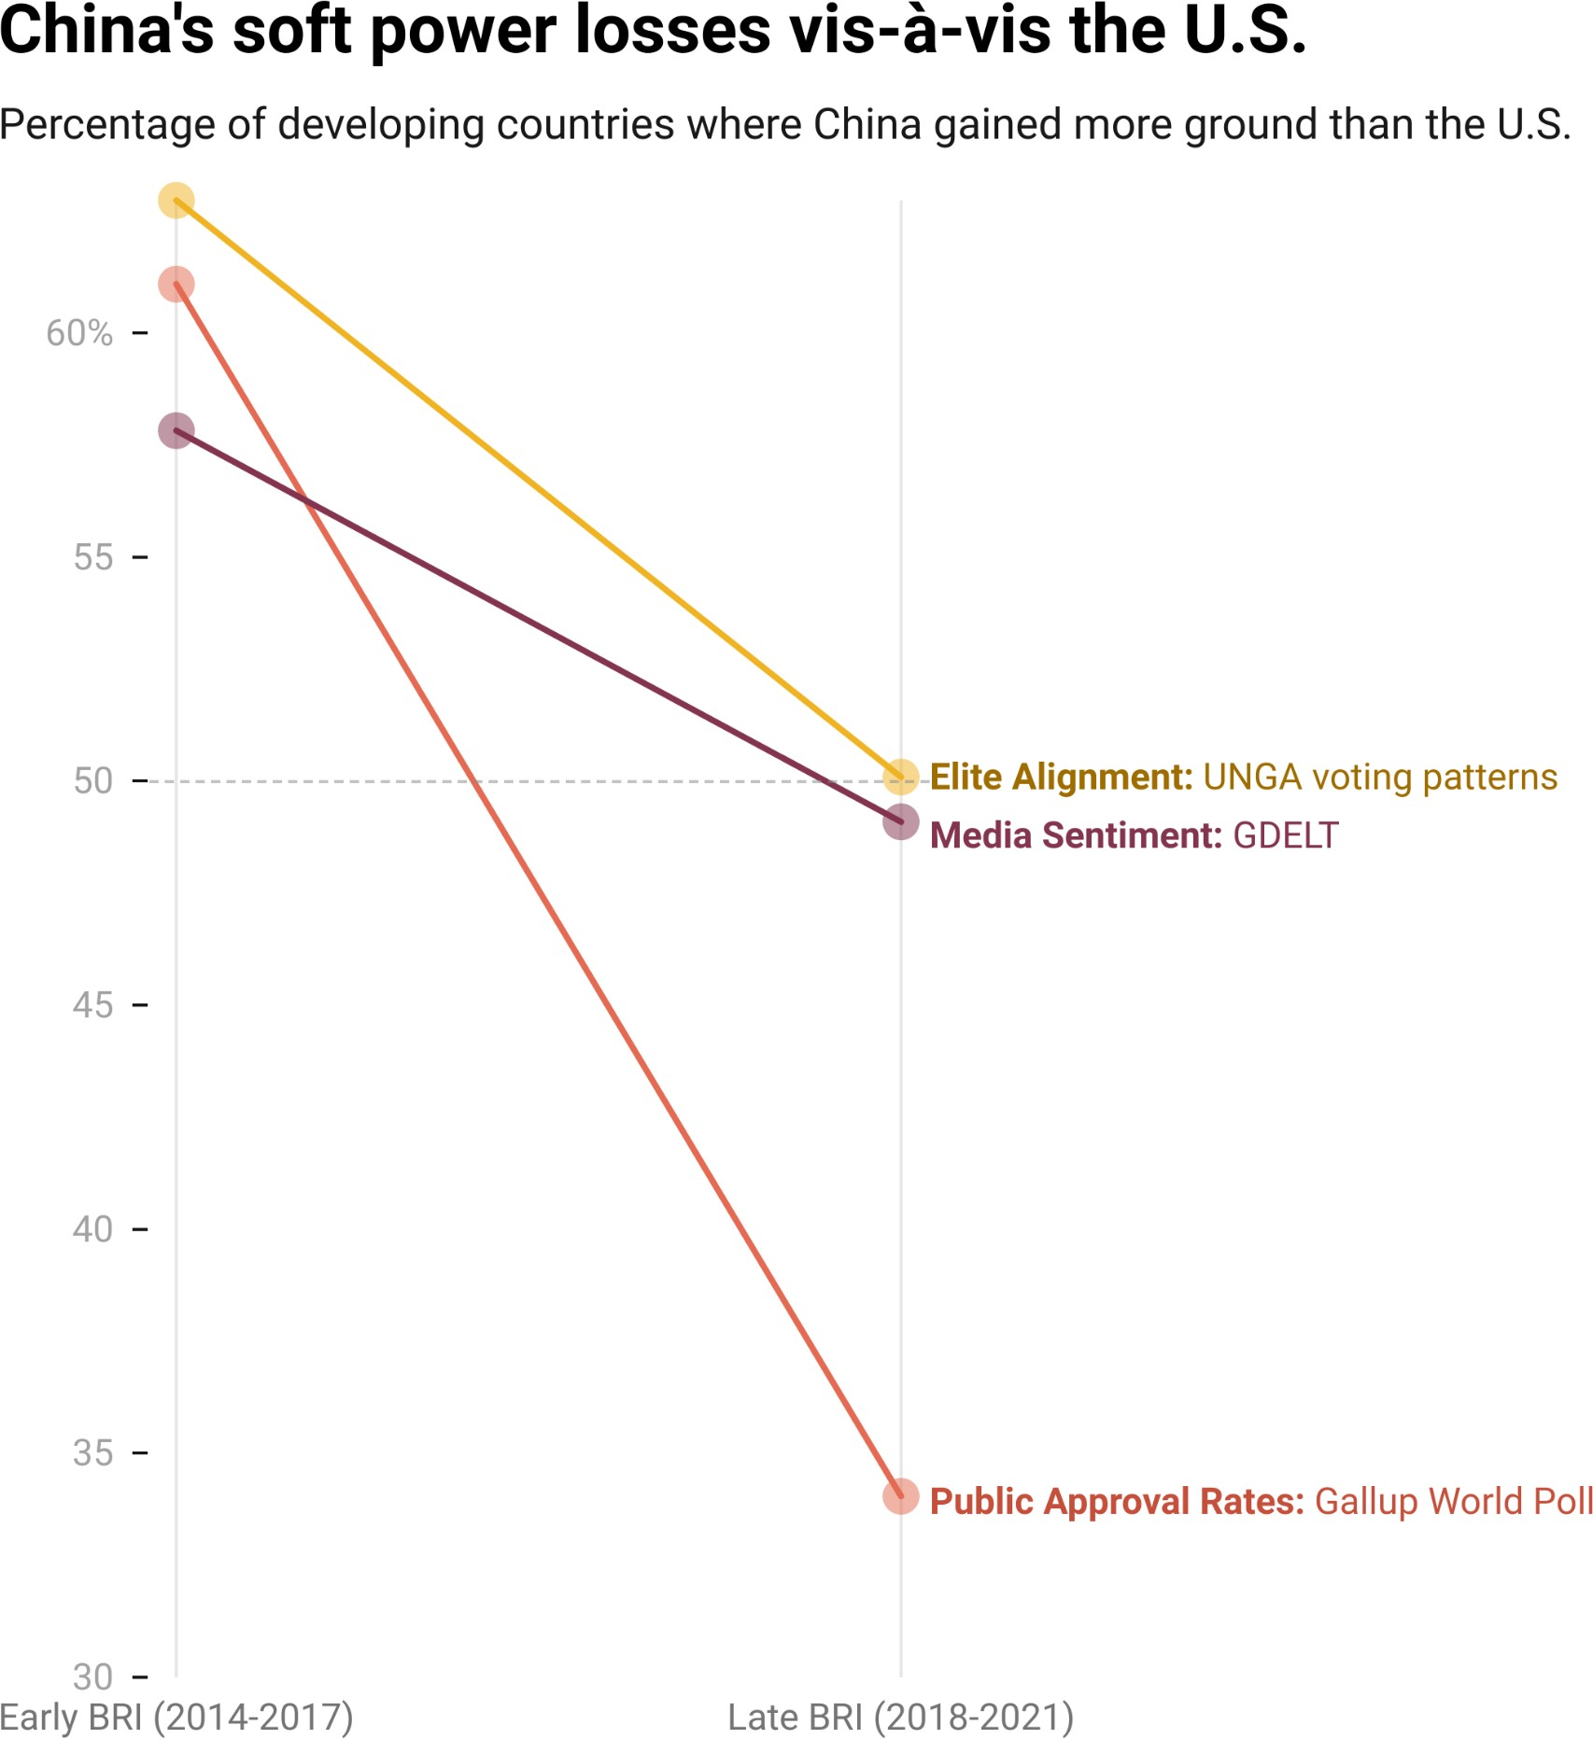

*Notes: China’s relative gains and losses in popular support, media sentiment, and UNGA voting alignment vis-à-vis the U.S are calculated on a country-by-country and year-by-year basis. The construction of these measures are described in greater detail in Box 1b and footnote 61.*

**Figure 1.18**

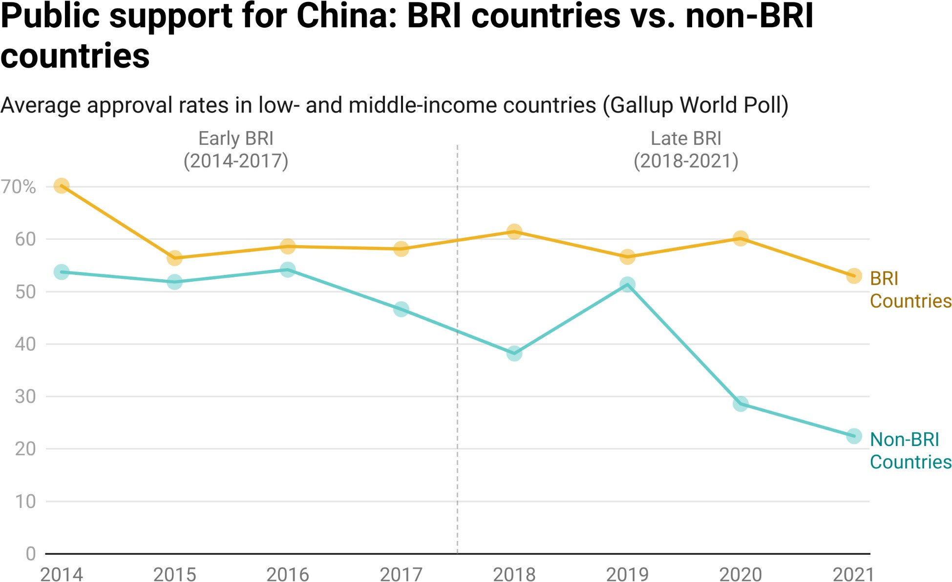

*Notes: Average public approval ratings for China are weighted by country population. The construction of this variable is described in greater detail in Box 1b.*

**Figure 1.19**

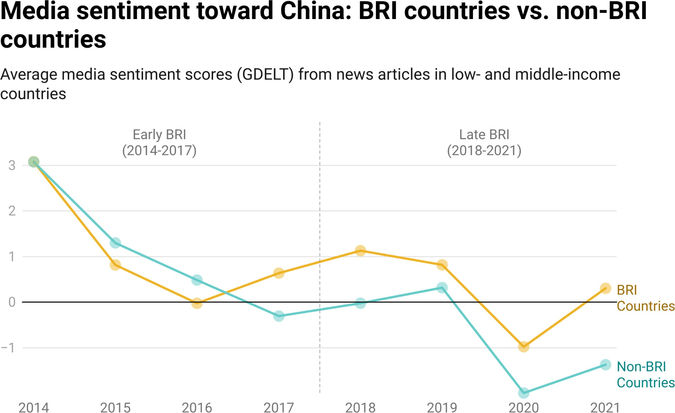

*Notes: Average media sentiment ratings for China are weighted by country population. The construction of this variable is described in greater detail in Box 1b.*

**Figure 1.20**

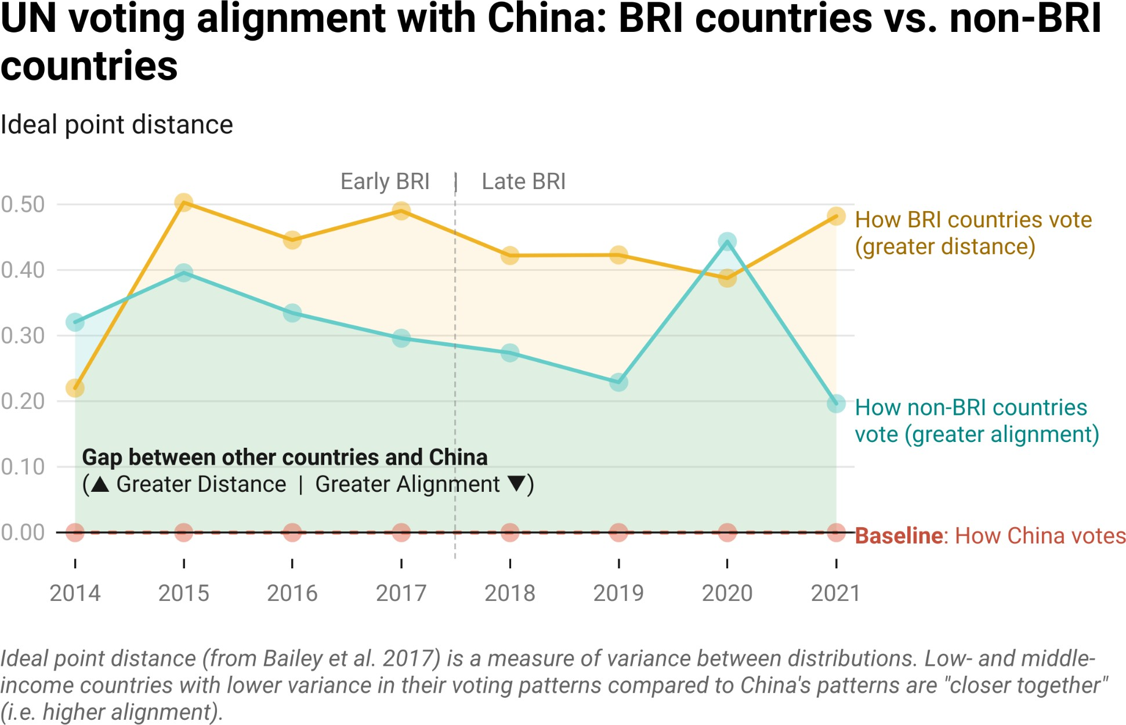

*Notes: Average UNGA voting alignment scores for China are weighted by country population. The construction of this variable is described in greater detail in Box 1b.*

### Section 6: The balancing act of portfolio risk management

Managing the risk proﬁle of China’s overseas development program is a multifaceted challenge. First, China has a high and rapidly rising level of exposure to non-performing loans in LICs and MICs. Its exposure to distressed debt is heavily concentrated among the most important Belt and Road participants, which raises the question of whether its efforts to get repaid will conﬂict with its foreign policy (and soft power) objectives (Hancock and Hill 2022).[65] The crux of the matter, as described by a senior ofﬁcial from China’s central bank, is that “debt reduction can shape China’s image as a responsible, major global player, [but] it often leads to big [ﬁnancial] losses and even causes a moral hazard—debtors may refuse to make repayments if they know [that we may write off their debts]” (Chengjun 2021). Second, a large share of China’s infrastructure project portfolio has signiﬁcant ESG risk exposure, and while there are many good reasons to de-risk the portfolio by adopting stronger safeguards, doing so could result in China losing a competitive edge in the global infrastructure market. China is no longer “the only game in town” for countries seeking external sources of infrastructure ﬁnancing, and the other major players in the market already offer high-quality infrastructure projects that beneﬁt from strong ESG safeguards. China has historically outcompeted G7 countries and the multilateral development banks on two key dimensions: speed and convenience. If these differentiators are no longer applicable, China may face a different type of problem: insufﬁcient demand for Chinese infrastructure ﬁnancing. Third, rising levels of public antipathy toward Beijing and a souring media environment have left China increasingly dependent on the good graces of political leaders in the Global South. One way to address this challenge would be to dust off an old playbook and cater to the parochial interests of host country politicians by plying them with lavish spending on pet projects—like presidential palaces—and amenities in major urban centers (such as museums, theaters, convention centers, and stadiums). An alternative approach would be to double down on public diplomacy efforts—such as scholarships, sister city initiatives, and content-sharing partnerships with local radio stations, television channels, and newspapers—to generate more favorable media coverage and inﬂuence public sentiment in BRI participant countries.

Beijing is clearly aware of the need to pivot and assume a “ﬁre-ﬁghting” role. It is rapidly refocusing its time, money, and attention on distressed borrowers, troubled projects, and sources of public backlash in the Global South. However, a longer-term reinvention of the BRI is also underway. As Beijing learns from past mistakes, it is recalibrating its lending and grant-giving practices and making efforts to future-proof its ﬂagship, global infrastructure initiative. The ambition of BRI 2.0 remains poorly understood—and underestimated—by those who make and shape policy in G7 countries. Washington, London, Paris, Berlin, Tokyo, Rome, and Ottawa are, for the most part, still formulating policy on the basis of evidence from the BRI 1.0 era.

The primary goal of this report is to explain how China is handling its new role as an international crisis manager in the short-run while engaging in a longer-run effort to future-proof the BRI. In the next three chapters, we attempt to answer the following questions:

* How is China coping with the rising tide of debt distress? What measures is it taking to reduce its exposure to non-performing loans?
* Is China stepping up its ESG risk mitigation efforts? If so, where, when, and how? Are its infrastructure projects with and without strong ESG safeguards faring differently during implementation?
* How does China manage reputational risk? What measures does it take to preserve grassroots, media, and elite support in host countries? Are Chinese development ﬁnance institutions learning from their past mistakes and recalibrating their policies and practices in BRI “buyer’s remorse” countries?
* What are China’s tolerance levels for repayment risk, project performance risk, and reputational risk?

However, we also want to introduce researchers, policymakers, and journalists to the “art of the possible” with the 3.0 version of AidData’s GCDF dataset. There are many additional questions that can now be answered because of the dataset’s uniquely comprehensive scope and unprecedented granularity.[66] Several new and improved features of the dataset merit special attention:

1. Donor and lender coverage: The 3.0 dataset captures projects and activities in LICs and MICs supported by 791 ofﬁcial sector donors and lenders in China. It also identiﬁes the participation of 1,225 co-ﬁnancing institutions—including Western commercial banks, multilateral development banks, and OECD-DAC development ﬁnance institutions that have chosen to collaborate or coordinate with Beijing—in Chinese grant- and loan-ﬁnanced projects and activities. A new feature of the 3.0 dataset is the inclusion of two “ﬂag” variables that allow for easy identiﬁcation of projects/activities that involve (a) non-Chinese ﬁnanciers or (b) multilateral institutions.
2. **Borrower and recipient coverage**: The 3.0 dataset identiﬁes 5,037 receiving (borrowing) institutions and categorizes each one by type (government agency, state-owned bank, state-owned company, special purpose vehicle/joint venture, intergovernmental organization, private sector, etc.), country of origin (recipient country, China, or a third country), and, when applicable, role (direct borrower or indirect borrower through an on-lending arrangement). In recognition of the fact that special purpose vehicles and joint ventures play an important role in China’s overseas lending program and often blur the lines between public and private debt (Malik et al. 2021; Malik and Parks 2021), we have also added two new variables to the latest version of the dataset: a measure of the extent of host government ownership and a measure of the extent of Chinese government ownership whenever the borrowing institution (receiving agency) is a special purpose vehicle or joint venture.[6][7] The 3.0 dataset also identiﬁes 422 institutions (“accountable agencies”) that have supported Chinese loan-ﬁnanced projects and activities by providing repayment guarantees, insurance policies, and collateral which can be seized in the event of default.[6][8]
3. Financial instrument coverage: The 3.0 dataset allows users to easily differentiate between the 10,291 grant-ﬁnanced projects/activities and 4,776 loan-ﬁnanced projects/activities. However, given that Beijing relies on an increasingly diverse set of debt instruments to ﬁnance its overseas development program in LICs and MICs, AidData has introduced a new loan categorization scheme in the latest version of the dataset that allows users to isolate speciﬁc types of loan instruments, including but not limited to bilateral loans, syndicated/club loans, interest-free loans, government concessional loans, preferential buyer’s credits, public investment loans, balance of payments (BOP) loans, M&A loans, working capital loans, inter-bank loans, reﬁnancing loans, deferred payment agreements, and pre-export ﬁnancing (PxF) agreements.
4. Borrowing terms and conditions: There is no other publicly available dataset of China’s overseas loan commitments with global coverage from 2000-2021 that identiﬁes borrowing terms and conditions at the transaction level. The 3.0 dataset identiﬁes 2,699 interest rates, 3,315 maturity lengths, 1,854 grace periods, 498 commitment fees, 480 management fees, and 2,537 grant elements across 4,776 loans in Africa, Asia, Oceania, Eastern and Central Europe, the Middle East, and Latin America and the Caribbean. It also identiﬁes 668 loans backed by third-party repayment guarantees, 529 loans supported by credit insurance policies, and 1,015 loans underpinned by one or more sources of collateral. Three additional dataset features are worth noting. First, in light of recent changes to the OECD’s grant element method of measurement (see Section A-2) and the growing importance of the World Bank/IMF-based method of measurement to determine if and when governments have complied with the non-concessional borrowing limits speciﬁed in their World Bank and IMF programs, we now provide three different grant element measures: one based on the OECD’s cash-ﬂow methodology, one based on the the OECD’s grant-equivalent methodology, and another based on the latest (post-2013) World

Bank-IMF methodology.[69] Second, in order to facilitate more accurate calculation of the “all-in” price of Chinese debt, we have introduced variables that measure (a) the default (penalty) interest rate that applies to a loan in the event of default (i.e., non-payment of principal, interest, or fees on their scheduled payment dates), and (b) the cost of credit insurance.[70] Third, to support future research on debt service to China, we have included two new measures in the 3.0 dataset: the calendar day on which the borrower was originally scheduled to make its ﬁrst loan repayment and the calendar day on which the borrower was originally scheduled to make its last loan repayment. Whenever possible, we have also documented disbursements, repayments, and amounts outstanding in the dataset’s “description” ﬁeld.

1. Spatial and temporal granularity: The 3.0 dataset provides an unprecedented level of detail on project commencement (implementation start) dates and project completion (implementation end) dates. It identiﬁes precise, calendar day-level commencement dates for 11,286 projects (backed by ﬁnancial commitments worth $767 billion) and calendar day-level completion dates for 11,542 projects (backed by ﬁnancial commitments worth $606 billion). By way of comparison, the 2.0 version of the GCDF dataset identiﬁed calendar day-level commencement dates for 5,539 projects (backed by ﬁnancial commitments worth $504 billion in constant 2021 USD) and calendar day-level completion dates for 6,061 projects (backed by ﬁnancial commitments worth $383 million in constant 2021 USD). The 3.0 dataset also provides data on the originally scheduled project commencement dates and completion dates, which has paved the way for the introduction of two new measures (“Deviation from Planned Implementation Start Date” and “Deviation from Planned Completion Date”) of to what degree projects ran (or are running) ahead of schedule or behind schedule.[71] Another important value addition to the 3.0 dataset is the level of geographical detail regarding where projects take place. As we describe in greater detail in Goodman et al. (2023), for 9,497 projects that have physical footprints or involve speciﬁc locations, the 3.0 dataset extracts point, polygon, and line vector data via OpenStreetMap URLs and provides a corresponding set of GeoJSON ﬁles and geographic precision codes.[72] 72% (6,919) of these projects include “precise” or “approximate” geocodes; the remaining 28% (2,578 projects) are measured at an administrative unit level.[73] Measuring the spatio-temporal rollout of project implementation with a high level of precision is important because it creates new opportunities to identify cause-and-effect relationships in rigorous ways.[74]
2. **Sectoral coverage:** The 3.0 dataset systematically tracks provision of ofﬁcial ﬁnancial ﬂows from China to LICs and MICs across all sectors. Every project/activity is assigned a 3-digit sector code based on OECD deﬁnitions and measurement criteria. This “methodological crosswalk” is important because it allows for cross-ﬁnancier comparisons—at global, regional, national, and subnational scales—since most ofﬁcial sources of international development ﬁnance (including OECD-DAC members and multilateral institutions) use the same criteria. It also facilitates analysis of sectoral patterns and trends over space and time.
3. **Qualitative detail:** The 3.0 dataset provides detailed project narratives that “tell the story” of each project in the “description” ﬁeld. The average length of each project narrative increased from 144 words in 2.0 dataset to 169 words in the 3.0 dataset. Whereas the project narratives in the 2.0 dataset consisted of 1.93 million words (roughly the same number of words one would ﬁnd in 19 full-length books), the project narratives in the

3.0 dataset consist of 3.48 million words (roughly the same number of words one would ﬁnd in 34 full-length books).[7][5] As we will demonstrate in

Chapter 3, these narratives are useful in that they document the risks and challenges that arose during project design and implementation (e.g., bankruptcies, scandals, protests, labor strikes, and criminal investigation) and how funding, receiving, implementing, and accountable institutions responded to these risks and challenges.

1. **Scale, diversity, quality, and transparency of sourcing**: The 3.0 dataset was assembled with 147,703 sources (including 99,393 unique sources in more than a dozen languages, of which 51,597 are ofﬁcial sources). By way of comparison, the 2.0 dataset was assembled with 91,356 sources (including 63,464 unique sources in more than a dozen languages, of which 34,075 were ofﬁcial sources). Whereas the average record in the 1.0 dataset was based upon 3.6 sources and the average record in the 2.0 dataset was based on 6.8 sources, the average record in the 3.0 dataset is based upon 7.0 sources. 87% of the records in the 3.0 dataset are underpinned by at least one ofﬁcial source. To expose our coding and categorization determinations to public scrutiny and promote replicable research ﬁndings, we disclose all of the sources that were used to construct the dataset at the individual record level, including hundreds of unredacted grant, loan, debt forgiveness, and debt rescheduling agreements (that AidData has never previously published).

# Annotation

1 The 2018 National Defense Strategy of the U.S. asserted that “[t]he central challenge to U.S. prosperity and security is the reemergence of long-term, strategic competition…[with] revisionist powers” (U.S. Department of Defense 2018). It called upon the U.S. government to "out-think, out-maneuver, out-partner, and out-innovate revisionist powers” (U.S. Department of Defense 2018). In October 2018, the U.S. Congress passed the Better Utilization of Investment Leading to Development (BUILD) Act, establishing a “full service” development ﬁnance institution to help the U.S. government compete with China around the globe. Then, in September 2019, it authorized the creation of a “Countering Chinese Inﬂuence” fund.  
  
2 Euractiv 2023.  
  
3 Belt and Road Forum for International Cooperation 2017.  
  
4 Quoted in Shepherd and Blanchard 2018.  
  
5 Morris et al. 2020; Dreher et al. 2022. In 2020, Beijing teamed up with eight multilateral institutions to establish the Multilateral Cooperation Center for Development Finance (AIIB 2021).  
  
6 We address this issue at greater length in Chapter 3. Also see Parks 2019; Malik et al. 2021; and Dreher et al. 2022.  
  
7 For example, when China’s biggest borrowers have experienced ﬁnancial distress, it has not called for coordinated debt reschedulings with all major creditors (Gardner et al. 2021; Bon and Cheng 2021).  
  
Instead, it has discreetly provided emergency rescue loans to ensure that such borrowers are sufﬁciently liquid to continue servicing their existing BRI project debts (Horn et al. 2023a, 2023b). Beijing has also spurned multiple invitations to join the Paris Club (the main venue for sovereign debt restructurings) and insisted upon loan contracts with clauses that expressly exclude Chinese debts from the Paris Club and other collective restructuring initiatives, thereby granting its state-owned creditors sole discretion to decide if, when, and how they will grant debt relief (Dreher et al. 2022; Gelpern et al. 2022).  
  
8 The European Union, Japan, Australia, and India have also launched a set of complementary initiatives—called Global Gateway, Partnerships for Infrastructure (P4I), the Blue Dot Network, and the India-Middle East-Europe Economic Corridor (IMEC)—that are designed to increase choice and competition in the global infrastructure ﬁnance market.  
  
9 At the third Belt and Road symposium in November 2021, Xi Jinping also called for better risk management in overseas infrastructure projects and discouraged Chinese companies from going to “chaotic and dangerous” places (State Council of the People's Republic of China 2021).  
  
10 The $1.34 trillion ﬁgure excludes the short-term “rollover” facilities described in Box 2c and Section A-3). It increases to $1.5 trillion when such facilities are included in the tally.  
  
11 All projects and activities in AidData’s GCDF dataset must qualify as ofﬁcial ﬁnancial ﬂows (ODA or OOF). For ease of exposition, in the remainder of this report, we refer to all such projects and activities as “projects.” The deﬁnitions of and measurement standards for ODA and OOF are described in Section A-2 of the Appendix.  
  
12 At the time, we estimated that China’s average annual development ﬁnance commitments amounted to  
  
$85.4 billion between 2013 and 2017 and average annual development ﬁnance commitments from the U.S. amounted to $37 billion over the same ﬁve-year period (Malik et al. 2021). However, the latest (3.0) version of the GCDF dataset demonstrates that China was outspending its rivals by a wider margin than we previously understood: average annual development ﬁnance commitments from China amounted to $117 billion between 2013 and 2017 and average annual development ﬁnance commitments from the U.S. amounted to $40.6 billion over the same ﬁve-year period (in constant USD 2021 prices). These historical revisions imply that Beijing was outspending Washington on a nearly 3-to-1 basis during the early years of the BRI.  
  
13 To see the annual percentage of China’s ofﬁcial ﬁnancial ﬂows to LICs and MICs provided via ODA and OOF, see Figure A1 in the Appendix.  
  
14 Since the ﬁrst full year of BRI implementation in 2014, no member of the G7 has outspent China. The individual members of the G7 spent between $2 billion and $61 billion a year on overseas development activities between 2014 and 2021. China spent between $74 billion and $142 billion a year between 2014 and 2021.  
  
15 In a recent stock-taking exercise, Nikkei Asia concluded that “initial optimism [for the BRI] has been replaced by disappointment over mismanagement, debt crises and corruption that have left many projects unﬁnished or incapable of fulﬁlling their promised potential (Aamir et al. 2022).  
  
16 In Chapter 2, we explain why AidData’s estimates of ofﬁcial sector lending commitments from China to LICs and MICs are substantially different from those recorded in other publicly available databases, such as the China's Overseas Development Finance Database, the Chinese Loans to Latin America and the Caribbean Database, the Chinese Loans to Africa Database, the China's Global Energy Finance Database, the China Overseas Finance Inventory Database, and the World Bank's International Debt Statistics (IDS).  
  
17 The rationale for evaluating “stocks” (cumulative ﬁnancial commitments) rather than “ﬂows” (annual ﬁnancial commitments) is that grants and loans are issued at speciﬁc points in time, but they disburse over many years and support projects implemented over many years.  
  
18 Section A-3 in the Appendix provides guidance for those who wish to use the 3.0 version of AidData's GCDF dataset to estimate cumulative stocks of ofﬁcial ﬁnancial ﬂows from China to LICs and MICs.  
  
19 China’s average annual international development ﬁnance (ODA/OOF) commitments amounted to $85 billion between 2014 and 2021 (excluding the short-term "rollover" facilities described in Box 2c and Section A-3). This ﬁgure rises to $105 billion if one includes short-term "rollover" facilities. Average annual international development ﬁnance (ODA/OOF) commitments from the U.S. amounted to $40 billion between 2014 and 2021.  
  
20 The $680 billion ﬁgure excludes the short-term "rollover" facilities described in Box 2c and Section A-3. It increases to $841 billion when such facilities are included in the tally.  
  
21 Total international development ﬁnance (ODA and OOF) commitments from the World Bank amounted to $307 billion from 2014-2021.  
  
22 While ofﬁcial ﬁnancial ﬂows (ODA and OOF) from the U.S. to LICs and MICs amounted to $61 billion in 2021, ofﬁcial ﬁnancial ﬂows from China to LICs and MICs amounted to $79 billion during the same year.  
  
23 U.S. OOF amounted to $1.4 billion in 2020 and $21.8 billion in 2021.  
  
24 Relatedly, Zeitz (2021) provides evidence that the World Bank is seeking to compete with China via emulation rather than differentiation.  
  
25 In July 2023 correspondence with AidData, the USAID ofﬁce responsible for ODA and OOF reporting to the OECD-DAC conﬁrmed that the full operation of the DFC in 2021 led to the major increase in U.S. OOF in 2021. See also DFC 2021a and DFC 2022. The DFC's transaction-level data, which is organized by ﬁscal year rather than calendar year, can be accessed via https://www.dfc.gov/our-impact/transaction-data.  
  
26 Akhtar and Brown (2021); Dreher et al. (2022).  
  
27 Sevastopulo and Long (2021); Landers et al. (2021).  
  
28 Bruni (2021). The January 2021 framework agreement between the DFC and Government of Ecuador can be accessed in its entirety via https://www.dropbox.com/s/oy377uc6wz8u9oe/Ecuador%20DFC%20January%202021%20Framework%20 Agreement.pdf?dl=0.  
  
29 DFC (2021b).  
  
30 The G7 failed to match China’s ODA and OOF commitments in 2014 and 2016 (see Figure 1.5).  
  
31 While China spent $93 billion a year on average between 2018 and 2021, the G7 spent $137 billion a year on average.  
  
32 In 2021, ofﬁcial ﬁnancial ﬂows (ODA and OOF) from all members of the G7 (combined) to LICs and MICs reached $163 billion, while ofﬁcial ﬁnancial ﬂows from China to LICs and MICs amounted to $79 billion.  
  
33 According to Figure A3, the percentage of China’s overseas development ﬁnance portfolio that supported three “hardware” sectors (Energy; Industry, Mining, and Construction; and Transport and Storage) declined from 68.3% in 2014 (the ﬁrst full year of the early BRI period) to 30.6% in 2021 (the last year of the late BRI period for which we have complete data). The percentage of China’s overseas development ﬁnance portfolio that supported the “Banking and Financial Services” sector and “General Budget Support” sector increased from 13.0% to 58.9% between 2014 and 2021. These two sectors capture emergency lending from China’s central bank (PBOC) to LIC and MIC central banks via currency swap arrangements, as well as emergency lending to ﬁnance LIC and MIC ﬁnance ministries via China’s State Administration of Foreign Exchange (SAFE), state-owned policy banks, state-owned commercial banks, and state-owned energy companies  
  
34 Beijing effectively created a backstop for highly exposed Chinese creditors by channeling emergency rescue loans to the subset of BRI participant countries that present major balance sheet risks (see Horn et al. 2023a, 2023b as well as the replication exercise that we conduct in Chapter 2).  
  
35 Chinese state-owned creditors have for the most part responded to this challenge via cash ﬂow relief (emergency rescue loans, grace period extensions, and/or maturity extensions), which suggests that they think their borrowers are illiquid but not insolvent (Horn et al. 2023a, 2023b). In a recent interview with Muyang Chen of Peking University, one policy bank ofﬁcial characterized the rising tide of debt distress in the developing world as “essentially a problem of liquidity” (Chen 2023: 1772).  
  
36 According to the World Bank’s International Debt Statistics (IDS), sovereign arrears from LICs and MICs to ofﬁcial sector creditors in China have also sharply increased in absolute terms (see Figure A5). However, due to the credit coverage and underreporting issues that affect IDS data (see Figure 2.1, Table A15, Horn et al. 2021, and Malik et al. 2021), the absolute amounts in Figure A5 should be interpreted with caution.  
  
37 Figure 1.8 draws inspiration from Figure 1 in Horn et al. (2023b), which relies on an earlier (2.0) version of AidData’s GCDF dataset. Both ﬁgures seek to measure the percentage of ofﬁcial sector Chinese lending to LIC and MIC borrower countries in distress, but in somewhat different ways. The shape of the line in Figure  
  
1.8 is different from the one in Horn et al. (2023b), in that the onset of exceptionally high levels of distress (in excess of 50%) begins in 2011 rather than 2022. Figure 1.8 also suggests that nearly 80% of China’s overseas lending to LICs and MICs is now supporting countries in distress. Horn et al. (2023b) estimate that the ﬁgure is closer to 60%, although they use a version of the GCDF dataset which captures 3,030 ofﬁcial sector loans from China rather than the 4,890 ofﬁcial sector loans from China captured in the 3.0 version (including 4,776 for approved, active, and completed projects/activities and 114 for suspended and canceled projects/activities).  
  
38 During the pre-BRI period (2000-2013), 32% of China's overseas lending portfolio supported borrowers in ﬁnancial distress on average each year. This ﬁgure increased to 79.7% during the early BRI period  
  
(2014-2017) and remained unchanged (79.7%) during the late BRI period (2018-2021).  
  
39 The sovereign credit ratings produced by Moody’s, Standard & Poor’s, and Fitch vary between AAA and  
  
D. Ratings of BB or lower are considered to be “junk territory.”  
  
40 We exclude all observations in years when a country maintained diplomatic relations with Taiwan (since the reported arrears may be to Taiwan).  
  
41 Once this dummy variable is set to 1 (“turns on") in a particular country-year, it retains a value of 1 (“stays on”) for that country until the end of the loan’s originally scheduled repayment period. The repayment period is calculated for each loan commitment (regardless of whether it was subsequently suspended or canceled) based on the originally scheduled ﬁrst repayment date (estimated by adding the grace period to the commitment date) and the originally scheduled ﬁnal repayment (maturity) date (estimated by adding the maturity to the commitment date). In cases where the grace period is unknown, the average grace period across all ofﬁcial sector loans from China to the same borrower country is applied. The variable never “turns on” for MOFCOM interest-free loans (which are typically issued without a credible expectation of repayment) or emergency rescue loans (responses to ﬁnancial distress).  
  
42 Sovereign arrears from LICs and MICs to ofﬁcial creditors in China have also sharply increased in absolute terms (see Figure A5).  
  
43 For more on the deﬁnition and measurement of the “infrastructure” variable, see Custer et al. (2023).  
  
44 Users of the 3.0 version of AidData’s GCDF dataset who wish to exclude suspended and canceled projects from their analysis can easily do so by using the “Recommended for Aggregates” ﬁlter or the “Status” variable.  
  
45 To calculate this ﬁgure, we ﬁrst determine which countries had ofﬁcially joined the BRI by the end of 2021, and then calculate the share of suspended and canceled projects in BRI participant countries between 2014 and 2021.  
  
46 Take for example the project to build a 97-km “oil road” connecting Masindi-Biso, Kabaale-Kiziranfumbi and Hohwa-Nyairongo-Kyarushesha-Butoole in Uganda (captured via ID#96073 in the 3.0 version of AidData’s GCDF dataset). In December 2021, Uganda’s Ministry of Finance withdrew its request for parliamentary authorization to contract a loan from China Construction Bank for the project. Therefore, AidData status-codes the project as “Pipeline: Pledge” rather than a suspension or cancellation of a ﬁnancial commitment.  
  
47 Figure 1.11 demonstrates that not only the proportion but also the overall size of Beijing’s infrastructure project portfolio (in constant 2021 USD) running behind schedule increased between the early BRI period and the late BRI period.  
  
48 This measure is derived from the “Deviation from Planned Implementation Start Date” and “Deviation from Planned Completion Date” variables in the 3.0 version of AidData’s GCDF dataset.  
  
49 Figure A7 provides evidence of a steady decline in average completion delays—from 571 days in 2000 to 220 days in 2021.  
  
50 Typically, the proceeds from a grant or loan from a Chinese state-owned entity are used by the recipient to ﬁnance a commercial contract between a “project owner” in the host country and a contractor from the ﬁnancier’s country of origin. The commercial contract typically speciﬁes an expected implementation start date and an expected completion (implementation end) date, but contractors and/or project owners can negotiate scope of work and timeline modiﬁcations.  
  
51 One potential reason why project completion dates are consequential for reputations is that they "erase any uncertainty about whether a project will actually reach completion” (Wellner et al. forthcoming). The same study does not ﬁnd that project commencement consistently delivers a public opinion dividend.  
  
52 The average ESG risk prevalence rate reached 54% during the early BRI (2014-2017) period and 47% during the late BRI (2018-2021) period (see Chapter 3 and Figure 44).  
  
53 Foreign powers undertake reputational risk management efforts that focus on the general public and the media because they believe that more favorable sentiment can “ﬁlter up and inﬂuence elite policy to be more amenable to [their own] interests” (Brazys and Dukalskis 2019: 567).  
  
54 Figure A9 in the Appendix provides evidence that this decline is not due to increased indifference toward China (i.e., the absence of active approval). It is because of an increase in active disapproval—from 44% in 2019 to 60% in 2021. High levels of active disapproval likely reﬂect multiple factors, including concerns about the local effects of Chinese development projects and how Beijing handled the COVID-19 pandemic (Silver et al. 2020; Blair et al. 2022a).  
  
55 We also generated two binary indicators that assume values of one if a respondent disapproves of the leadership of China or the leadership of the U.S., respectively. We dropped all "Don't Know" and "Refused to Answer" observations.  
  
56 GDELT event records are recorded in a dyadic format, with two actors and an action performed by Actor 1 on Actor 2 (e.g., the provision of aid from one country to another country, a leader from one country visiting another country). For the purposes of our analysis, we restrict Actor 1 to the LICs and MICs that are covered by the 3.0 version of the GCDF dataset and Actor 2 to China and the U.S. We also restrict our analysis to event records where the actor2type1code variable is set to GOV (in order to ensure that we are measuring media sentiment about the Chinese Government and the U.S. Government, respectively).  
  
57 Although the “one country, one vote” rule applies in UNGA, we report population-weighted estimates of UNGA voting alignment in chapters 1 and 4 because we use this measure as a proxy for elite support of China and the U.S. (rather than as a direct measure of an empirical phenomenon of interest). We also report population-weighted estimates of grassroots support (via Gallup World Poll) and media support (via GDELT) in chapters 1 and 4. This approach is based on the assumption that large countries are more important to China (and the U.S.) than small countries, regardless of the soft power outcome that is being sought.  
  
58 However, in relative terms, the U.S. gained ground on China between 2014 and 2021 (see Figure 1.17.  
  
59 To be sure, China is not the only major power that has used foreign aid and credit to inﬂuence the foreign policy positions of developing countries (Alesina and Dollar 2000; Kuziemko and Werker 2006; Vreeland and Dreher 2014; Rose 2018).  
  
60 We thank Axel Dreher, Andreas Fuchs, Austin Strange, and Mike Tierney for generating and sharing supplementary evidence derived from a statistical model in the ﬁfth chapter of Banking on Beijing.  
  
61 Figure 1.17 present the percentages of LICs and MICs in which China experienced relative gains or losses in popular support, media sentiment, and UNGA voting alignment vis-à-vis the U.S. The percentages are reported over two time periods: early BRI (2014-2017) and late BRI (2018-2021). To measure the relative gains or losses in popular support, we follow a three-step calculation for each country: (1) calculate the difference between the public approval rating for China in a given year and the prior year; (2) calculate the difference between public approval rating for the U.S. in a given year and the prior year; and (3) calculate the “double difference” between (1) and (2) to determine if China experienced a greater gain or loss in public support than the U.S. in the same country-year. For relative gains and losses in media sentiment and UNGA voting alignment, the same three-step calculation was followed using the average media sentiment score for each country-year from the GDELT 1.0 Event Database (related to government actors from mainland China or the U.S.) and the average “idealpointdistance” estimate between each country and China (or the U.S.) in a given year.  
  
62 During the ﬁrst three years of the early BRI period (2014-2016), 55% of the public opinion changes that China experienced at the country-year level vis-à-vis the U.S. were relative gains and 45% were relative losses. Over the full early BRI period (2014-2017), 61% of the public opinion changes that China experienced at the country-year level vis-à-vis the U.S. were relative gains and 39% were relative losses (see Figure A8).  
  
63 During the late BRI period (2018-2021), 39% of the public opinion changes that China experienced at the country-year level vis-à-vis the U.S. were relative gains and 61% were relative losses (see Figure A8).  
  
64 BRI participant countries include those countries that have signed MOUs with China to join its Belt and Road Initiative. A country is assigned to the BRI participant cohort in the year it signed the MOU and every year thereafter.  
  
65 Beijing’s exposure to distressed debt in LICs and MICs also raises the question of whether certain borrowers are “too big to fail” and whether Chinese creditors will strictly adhere to the principle that every loan must be repaid in full (an issue we address at greater length in Chapter 2).  
  
66 Table A1 presents a broad view of how the 3.0 version compares to the 2.0 version of the GCDF dataset.  
  
67 These new variables are called “JV/SPV Host Government Ownership” and “JV/SPV Chinese Government Ownership.” The 3.0 dataset captures 851 loan commitments worth $315 billion (in constant 2021 USD) to borrowing institutions that are categorized as special purpose vehicles or joint ventures.  
  
68 Consistent with the 2.0 version of the GCDF dataset, each accountable agency in the 3.0 dataset is still categorized by type and country of origin. However, unlike the 2.0 version of the GCDF dataset, each accountable agency in the 3.0 dataset is also categorized by role (guarantor, insurance provider, or collateral issuer).  
  
69 The OECD’s cash-ﬂow methodology assumes a ﬁxed, 10 percent discount rate. Its grant-equivalent methodology uses ﬁxed discount rates that depend on the income level of the borrowing country (9% for LDCs and other LICs and 6% for UMICs). The World Bank-IMF methodology assumes a ﬁxed, 5 percent discount rate. For more on the IMF’s Debt Limits Policy (DLP), see https://www.imf.org/en/Topics/sovereign-debt/debt-limits-policy.  
  
70 For example, Argentina’s Ministry of Economy and Public Finance signed a $4,714,350,000 syndicated term facility (loan) agreement on August 1, 2014 with Bank of China, China Development Bank, and ICBC for the 1,740 MW Néstor Kirchner and Jorge Cepernic Hydroelectric Power Plant Construction Project. The  
  
loan agreement, which was later amended on January 27, 2015 and again in mid-2022, speciﬁes a default (penalty) interest rate of 1.5%. As a credit enhancement, the borrower purchased a buyer’s credit insurance policy from Sinosure worth approximately 7.1% of the face value of the loan ($502,976,000) (see Project ID#59723, 59724, 37002 in the 3.0 version of the GCDF dataset).  
  
71 The “Deviation from Planned Implementation Start Date” variable captures the difference between the “Planned Implementation Start Date” and the “Actual Implementation Start Date” when values are recorded for both variables. It captures the difference as the number of calendar days, whereby positive values represent cases where the project started implementation ahead of schedule and negative values represent cases where the project started implementation behind schedule. The “Deviation from Planned Completion Date” variable captures the difference between the “Planned Completion Date” and the “Actual Completion Date” when values are recorded for both variables. It captures the difference as the number of calendar days, whereby positive values represent cases where the project was completed ahead of schedule and negative values represent cases where the project was completed behind schedule.  
  
72 Users who wish to conduct analysis at higher levels of spatial aggregation can ﬁnd the ADM1s (provinces) and ADM2s (districts) that correspond to these project locations in the 3.0 version of the GCDF dataset.  
  
73 A project with “precise” geocodes is one for which we have highly precise boundaries of the project’s geofeature(s). A project with “approximate” geocodes is one identiﬁed within a 5-km radius of the precise boundaries of the project’s geofeature(s). For more details, see Goodman et al. (2023).  
  
74 To better understand how highly precise data on the spatio-temporal rollout of Chinese grant- and loan-ﬁnanced projects make it possible to estimate the causal effects of such projects on intended and unintended outcomes, see Dreher et al. (2019, 2022), Marty et al. (2019), Blair et al. (2022), Baehr et al.  
  
(forthcoming), Isaksson and Kotsadam (2018a, 2018b), Isaksson (2020), Martorano et al. (2020), Iacoella et al. (2021), Malik et al. (2021), Bluhm et al. (2020), Anaxagorou et al. (2020), Wellner et al. (forthcoming), and Asmus et al. (forthcoming).  
  
75 A typical, full-length book includes 100,000 words.